Organic Closed Curved Shapes
# Source: AI Source: Provided by: [Data Path: Persons Table -> ID Column: 1, Name_En Column: Motasem Essam] -> From: [ChatGPT] on [7/25/2026]
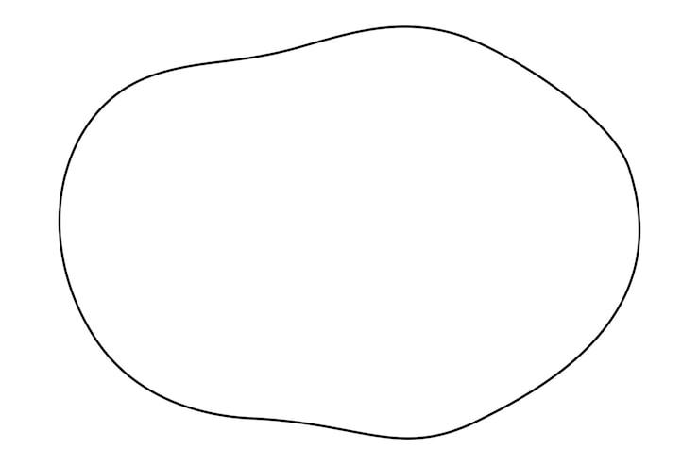
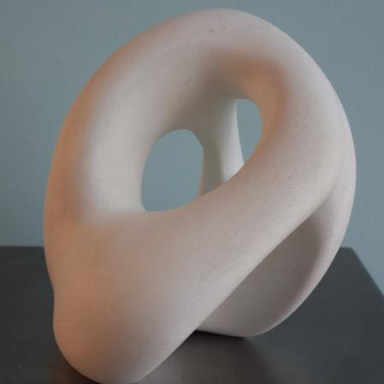
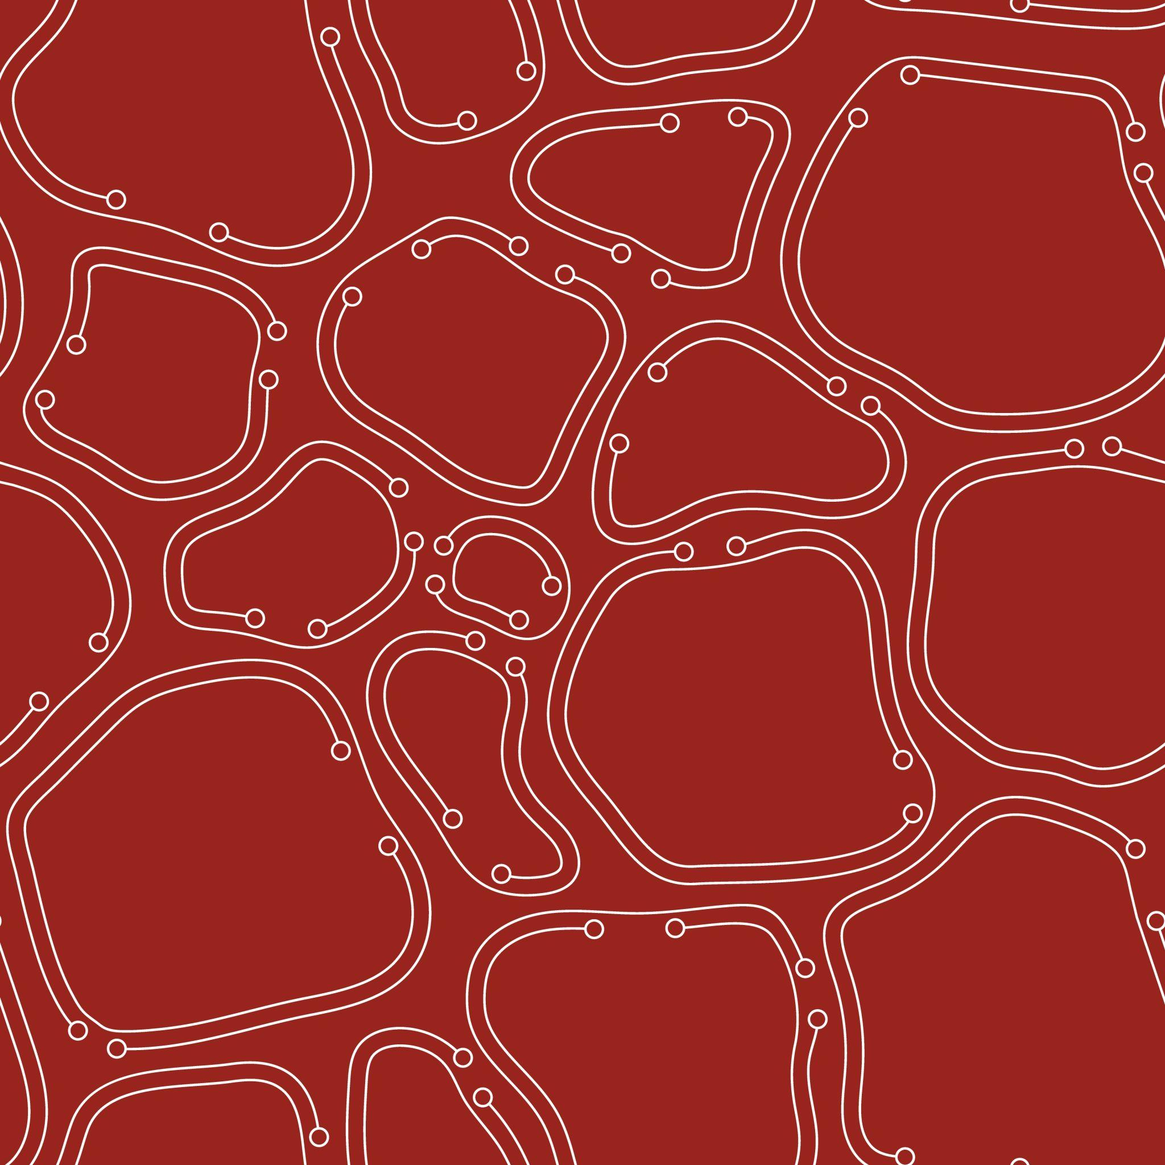
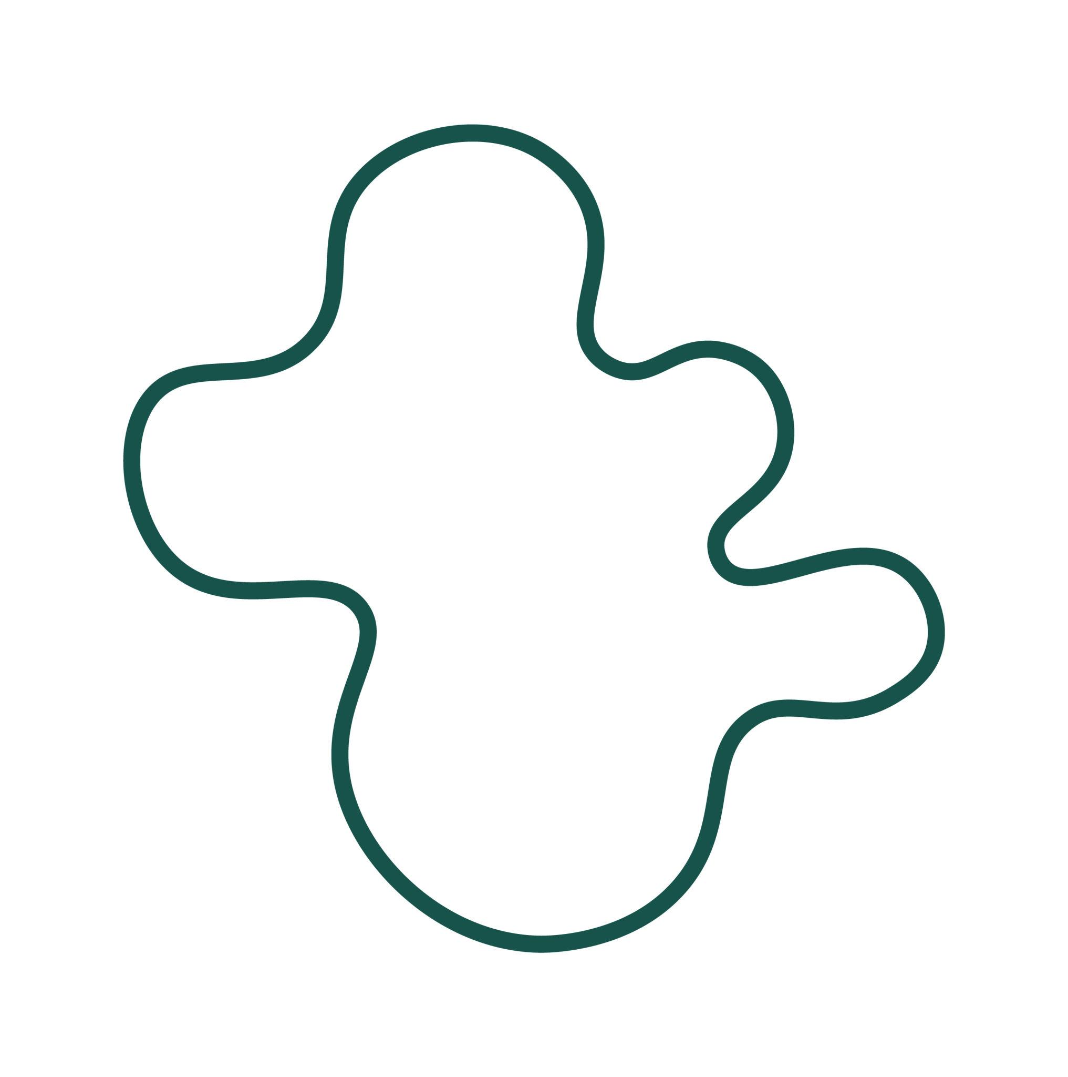
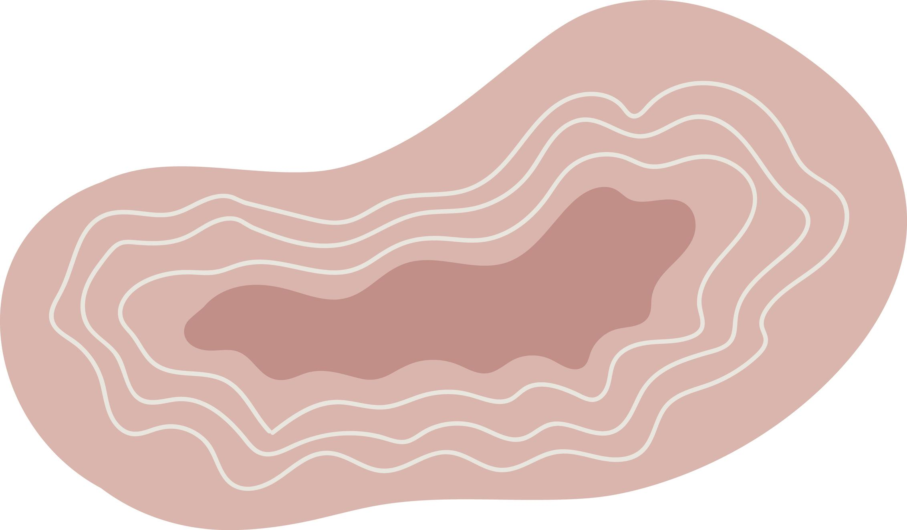

Definition
# Source: AI Source: Provided by: [Data Path: Persons Table -> ID Column: 1, Name_En Column: Motasem Essam] -> From: [ChatGPT] on [7/25/2026]
An Organic Closed Curved Shape is a closed curved shape with a smooth, natural-looking, irregular boundary that encloses a bounded region.
The term organic describes the shape's natural or biological appearance rather than a specific mathematical equation.
$$\boxed{\text{Organic Closed Curved Shape}=\text{Closed}+\text{Curved}+\text{Natural-Looking}+\text{Irregular}}$$
Examples can resemble:
- Leaves
- Pebbles
- Clouds
- Seeds
- Cells
- Natural body outlines
- Puddles
- Organic objects

Characteristics
# Source: AI Source: Provided by: [Data Path: Persons Table -> ID Column: 1, Name_En Column: Motasem Essam] -> From: [ChatGPT] on [7/25/2026]
An organic closed curved shape typically:
- Is closed.
- Has a continuous curved boundary.
- Has no open endpoints.
- Encloses a bounded region.
- Has no straight sides in its pure form.
- Has no sharp vertices.
- Has smoothly varying curvature.
- Does not necessarily follow a standard geometric equation.
- May be asymmetric.
- Usually has an irregular or non-uniform form.
The defining closed condition is:
$$\boxed{P_{\text{start}}=P_{\text{end}}}$$

Types of Organic Closed Curved Shapes

1. Leaf-Like Organic Closed Curves
# Source: AI Source: Provided by: [Data Path: Persons Table -> ID Column: 1, Name_En Column: Motasem Essam] -> From: [ChatGPT] on [7/25/2026]
These shapes resemble the outline of leaves.
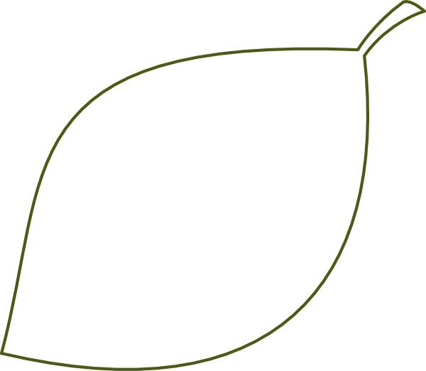
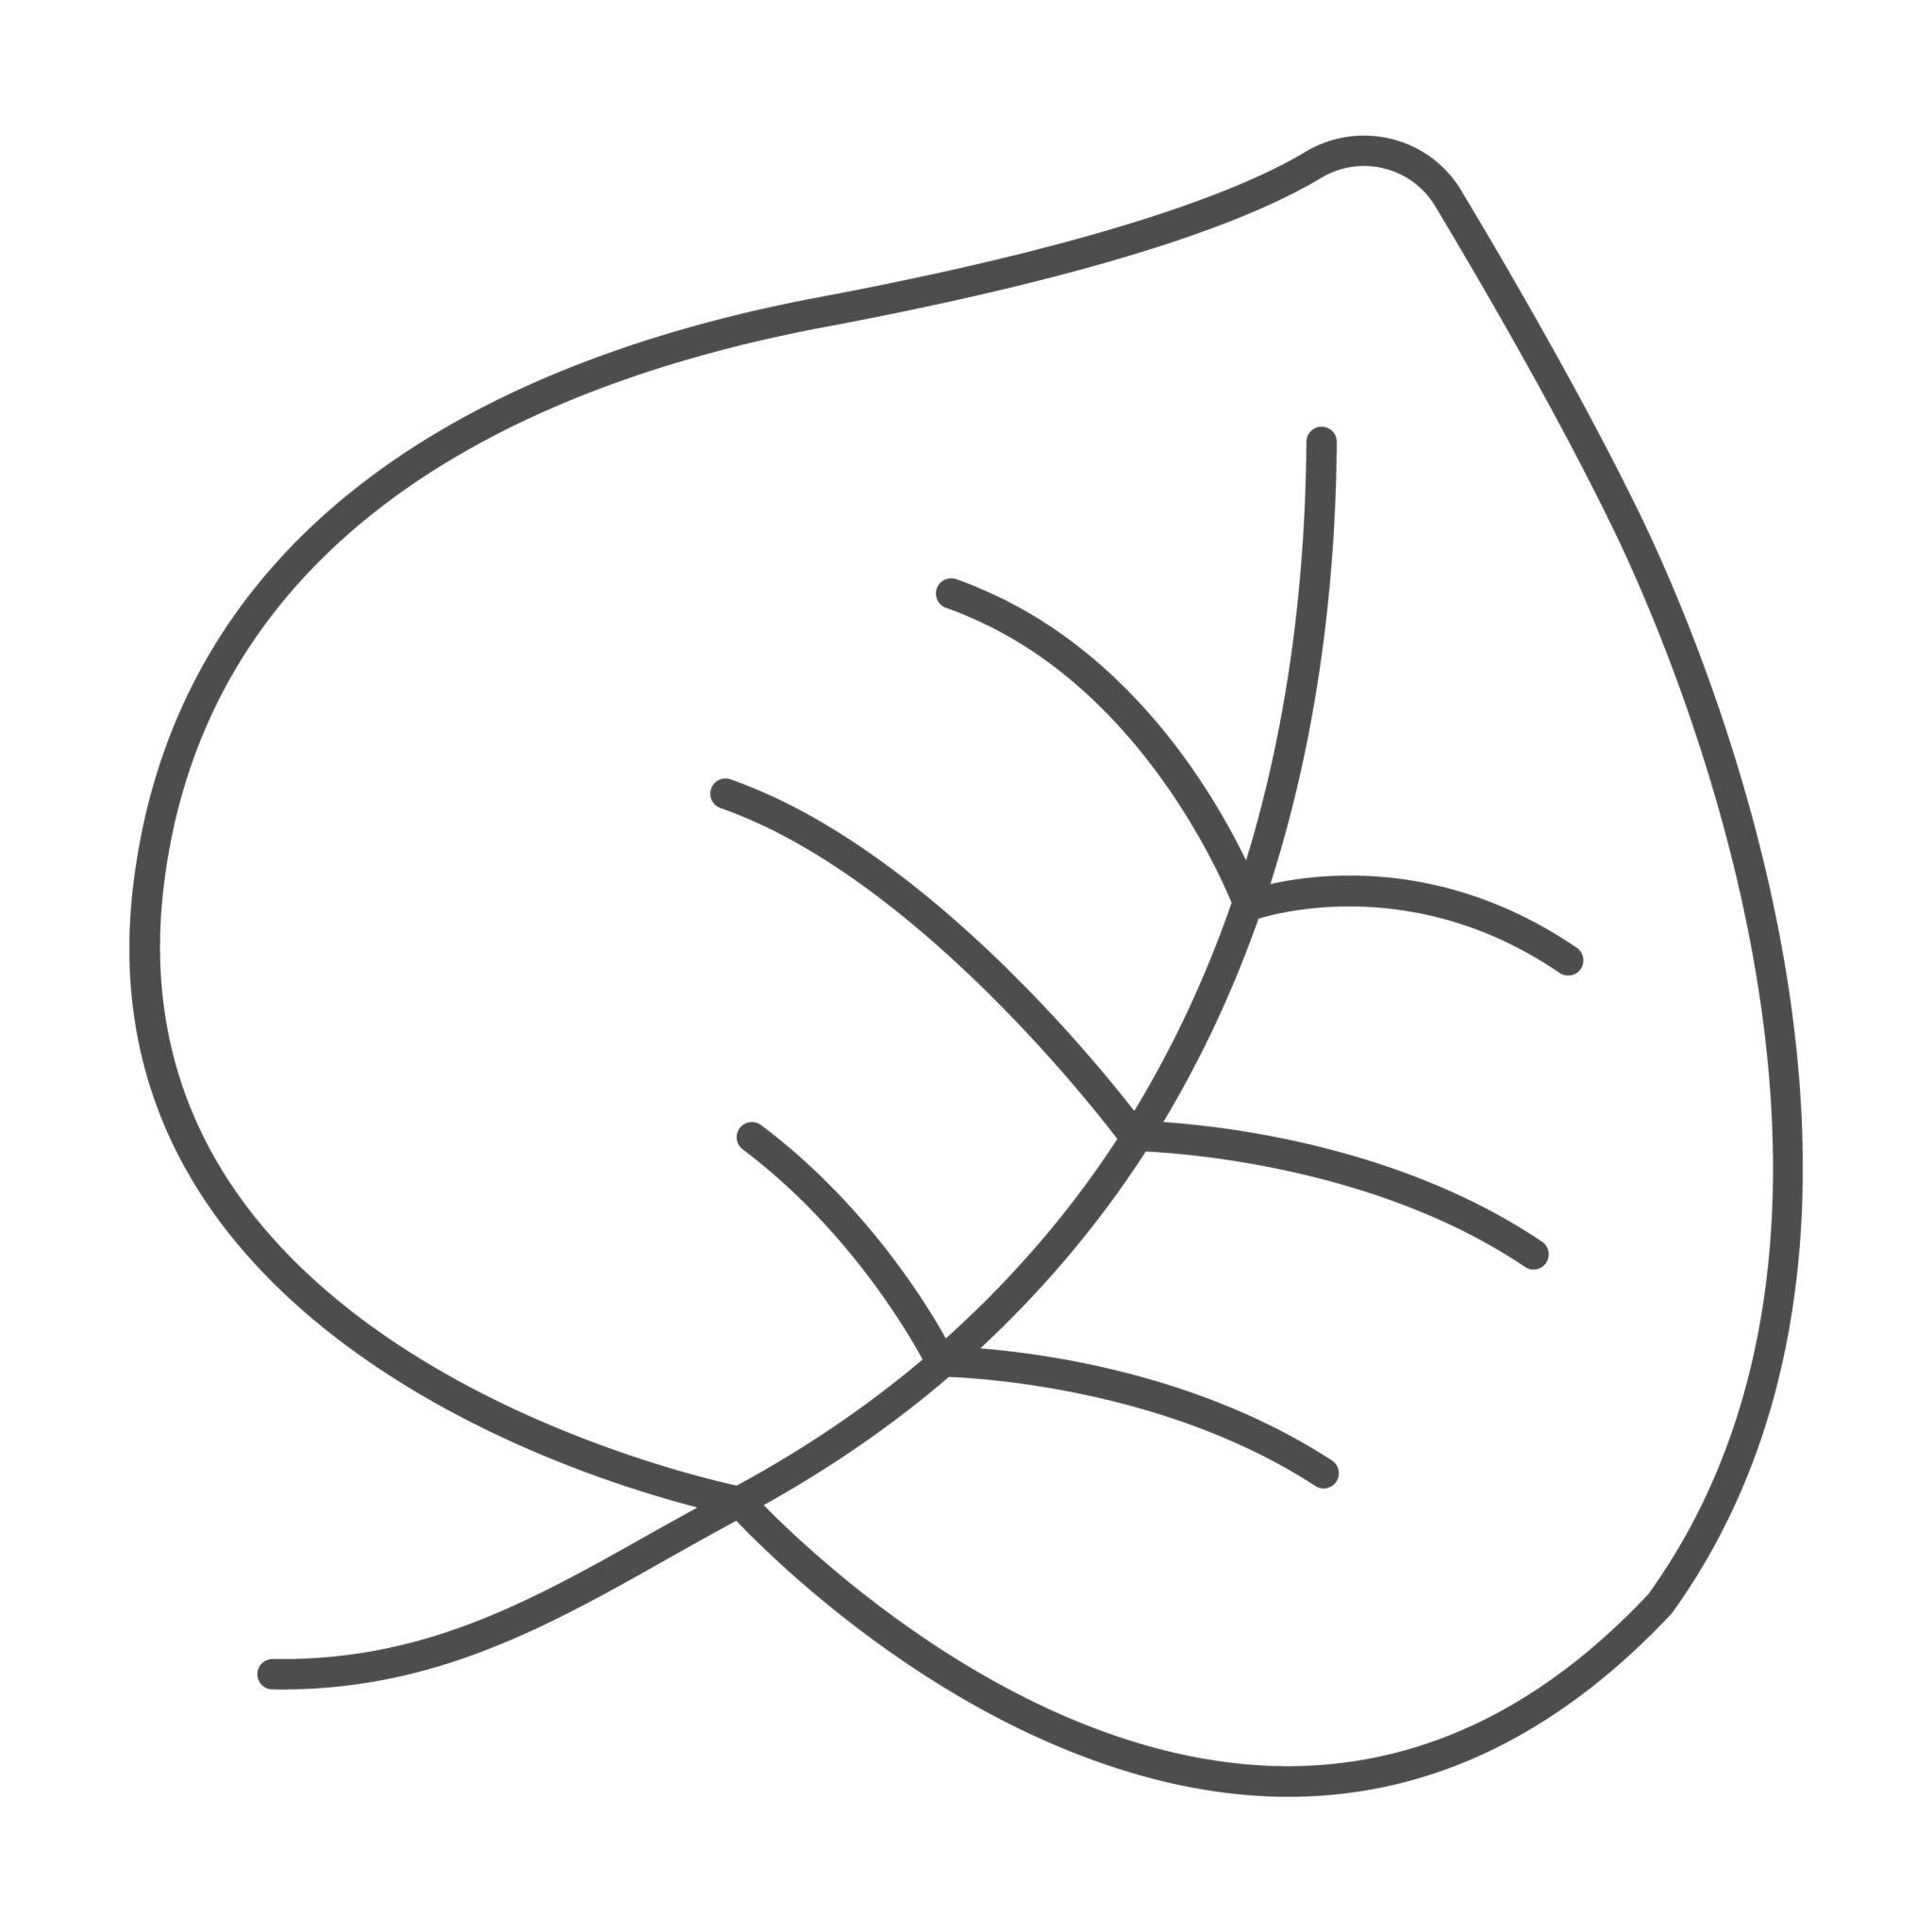
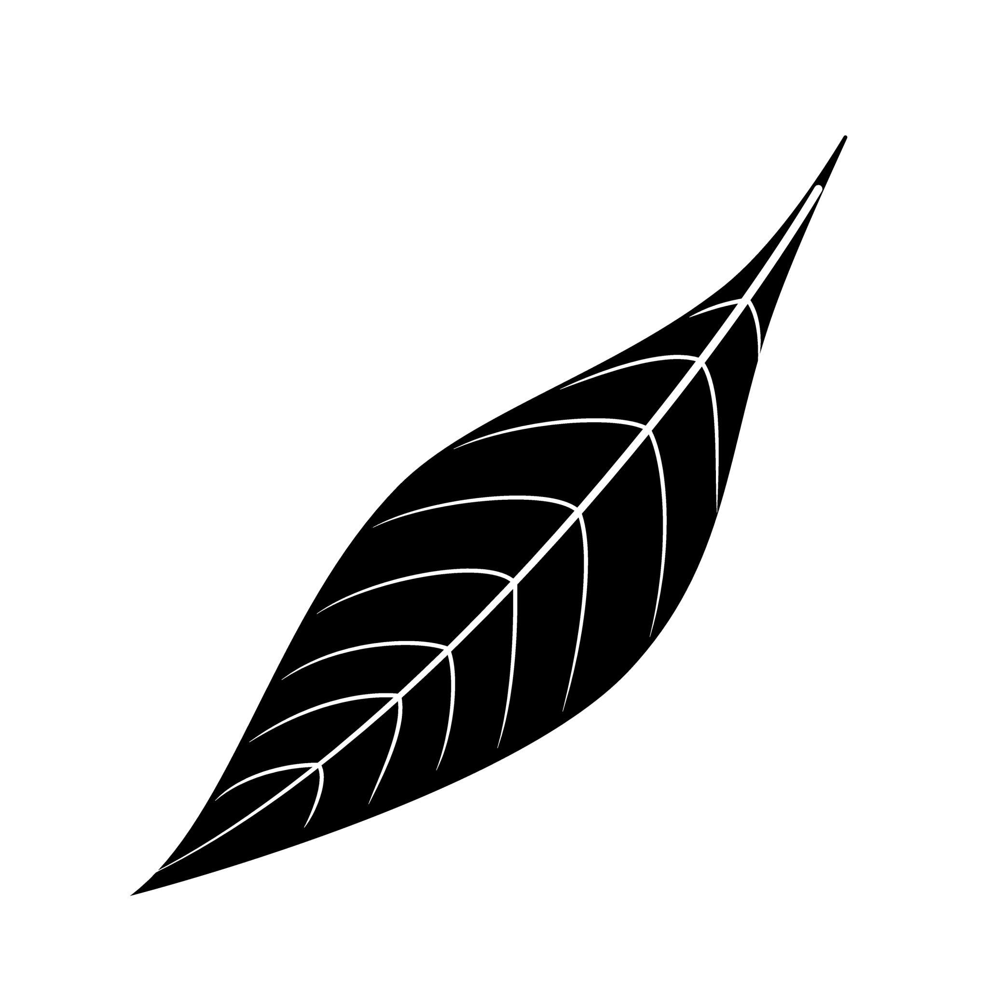
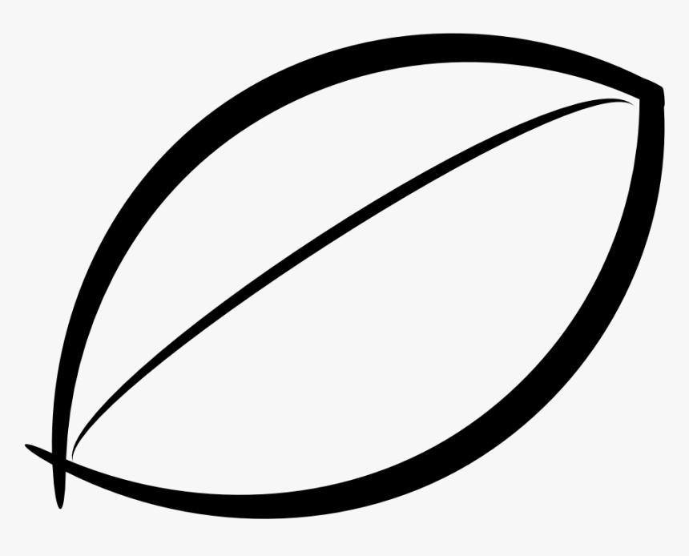
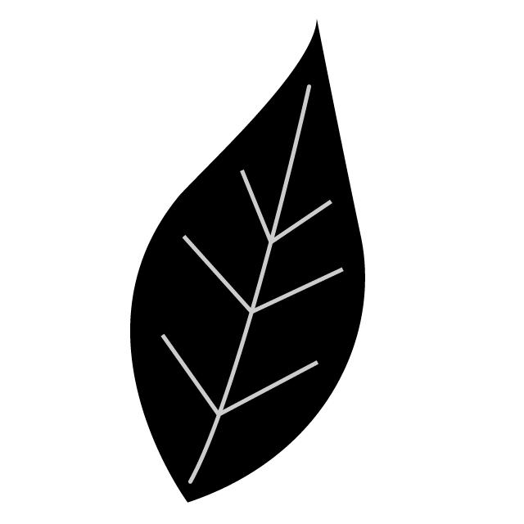
They may be:
- Symmetric.
- Slightly asymmetric.
- Pointed at one or both ends.
- Smoothly curved.

2. Pebble-Like Organic Closed Curves
# Source: AI Source: Provided by: [Data Path: Persons Table -> ID Column: 1, Name_En Column: Motasem Essam] -> From: [ChatGPT] on [7/25/2026]
These resemble naturally formed stones or pebbles.
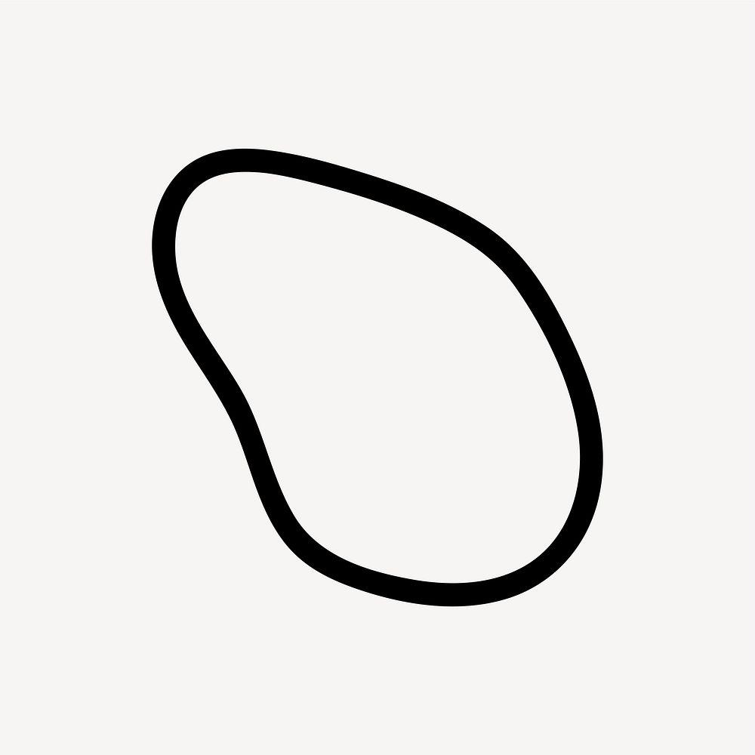
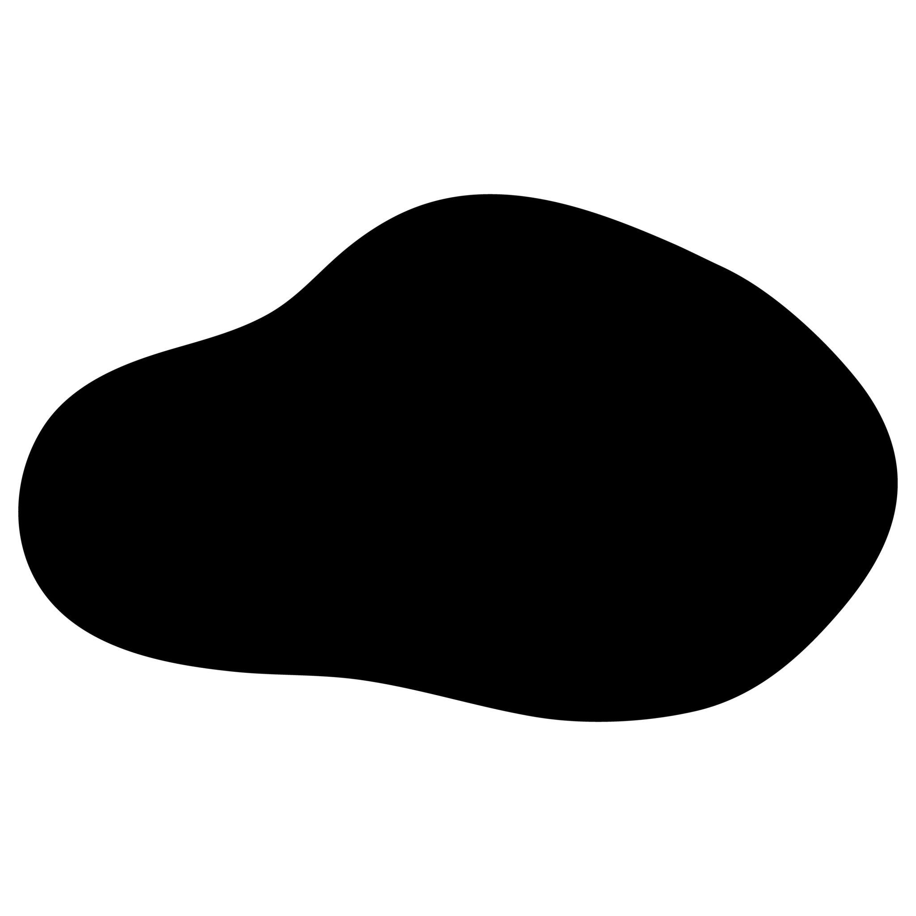
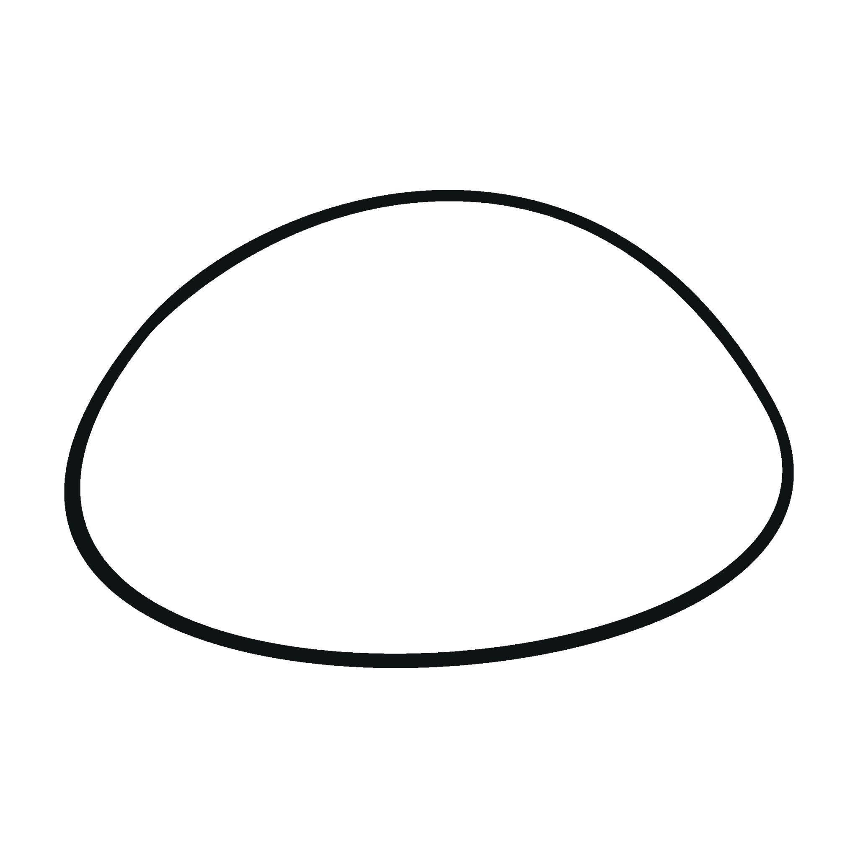
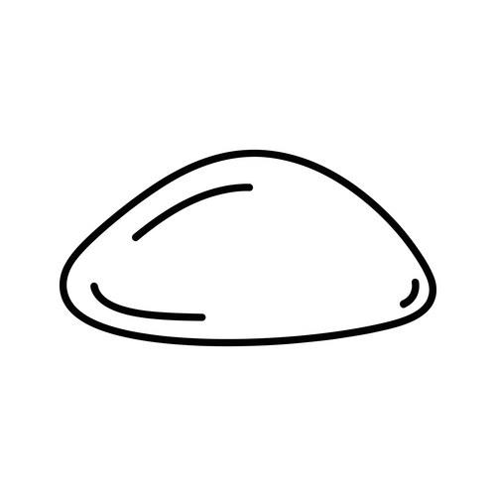
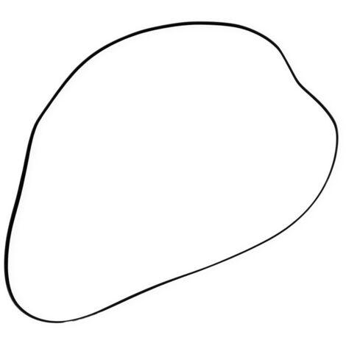
Their boundaries usually have:
- Unequal curvature.
- No exact geometric center.
- No regular repeating pattern.

3. Cloud-Like Organic Closed Curves
# Source: AI Source: Provided by: [Data Path: Persons Table -> ID Column: 1, Name_En Column: Motasem Essam] -> From: [ChatGPT] on [7/25/2026]
These are rounded closed curves with multiple smooth bulges and indentations.
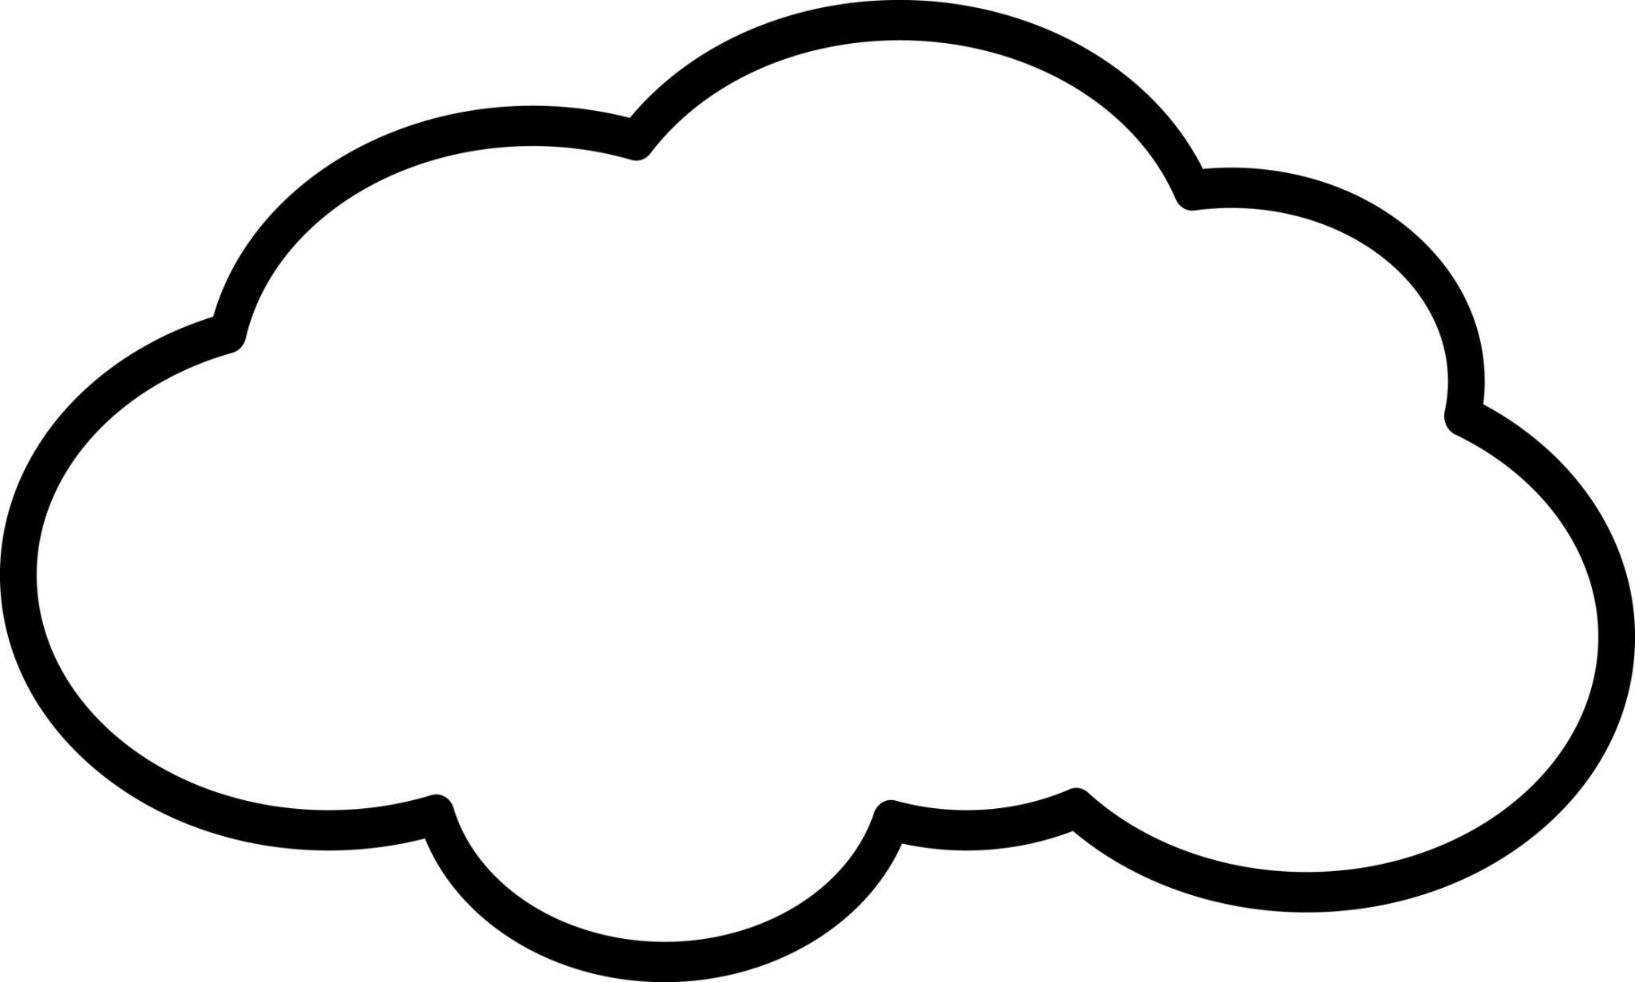
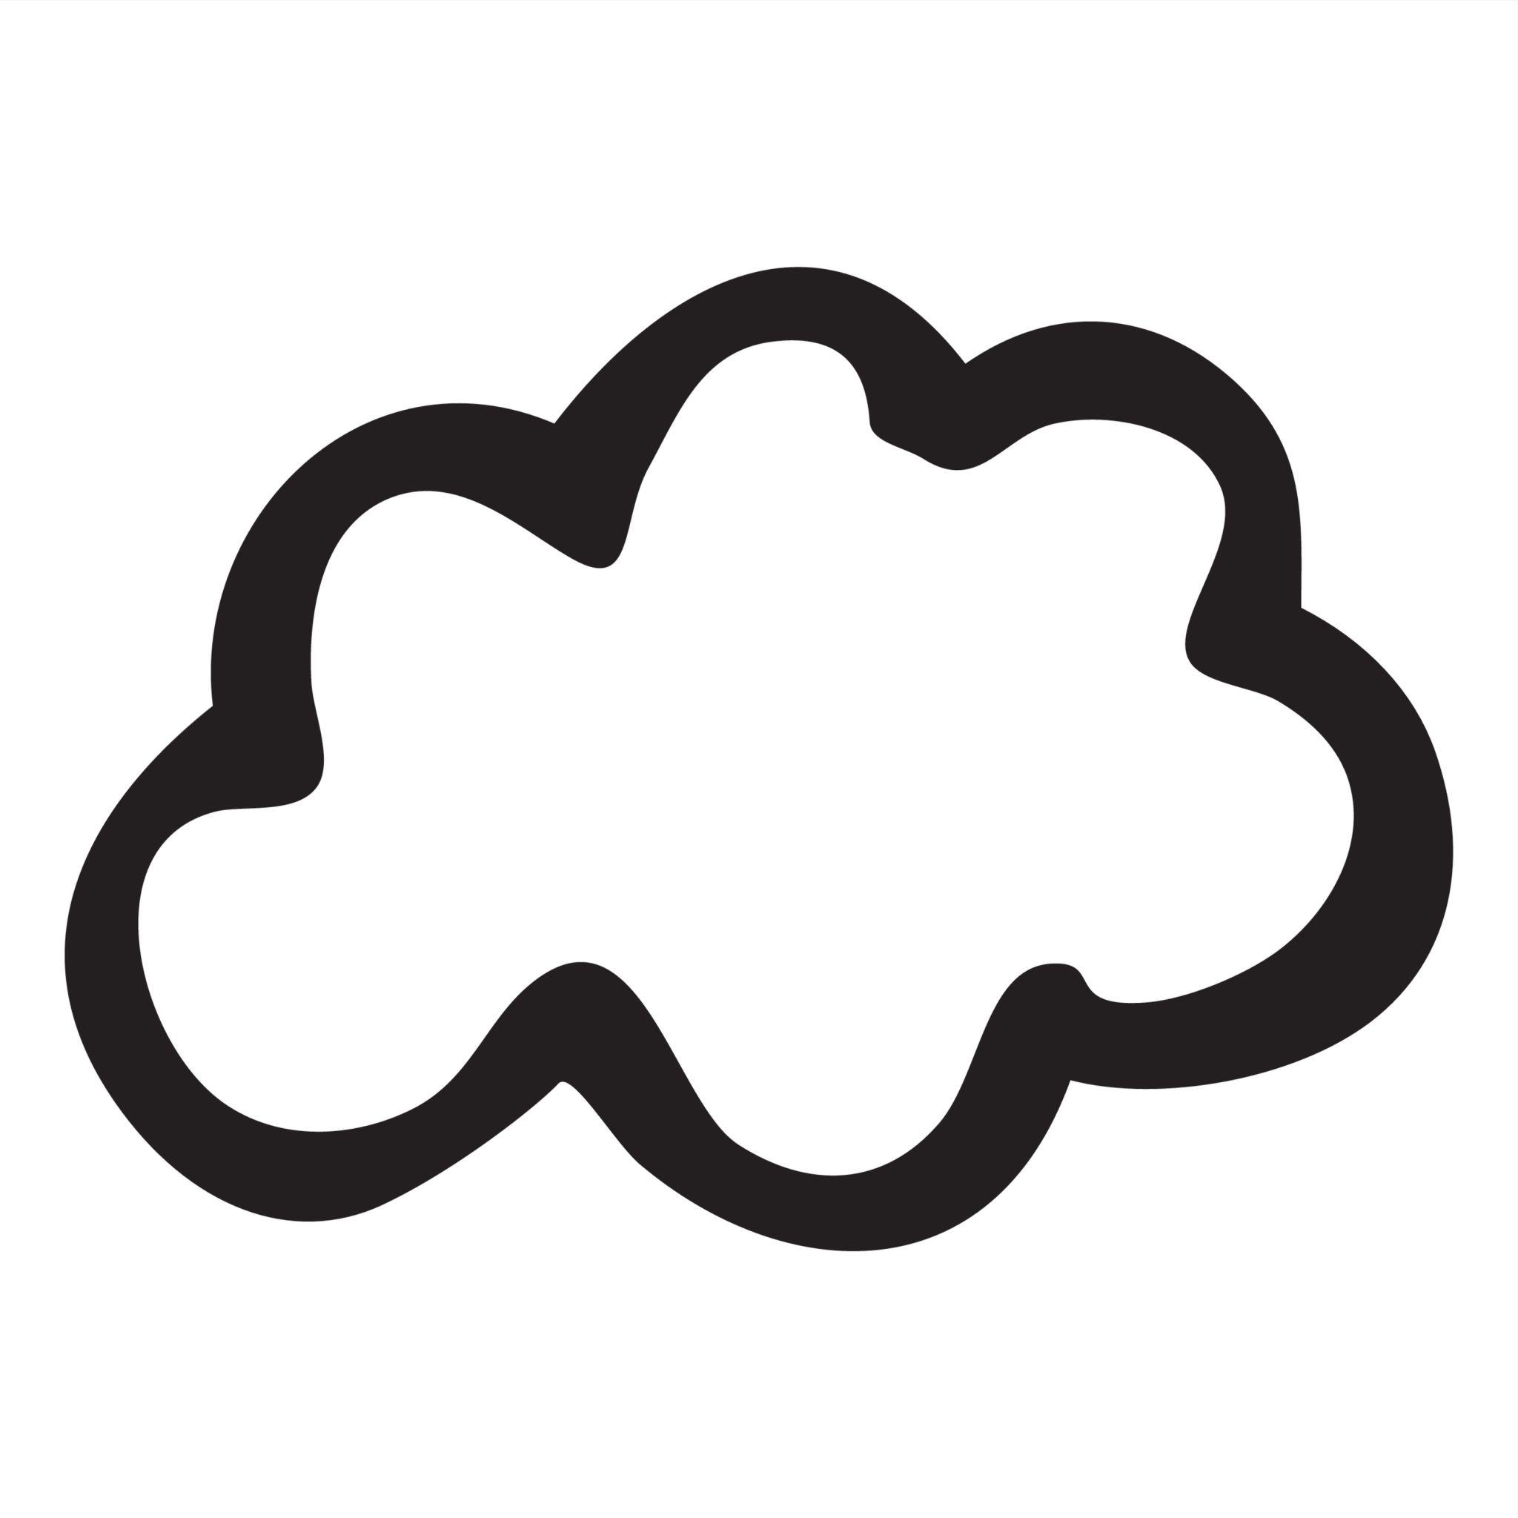
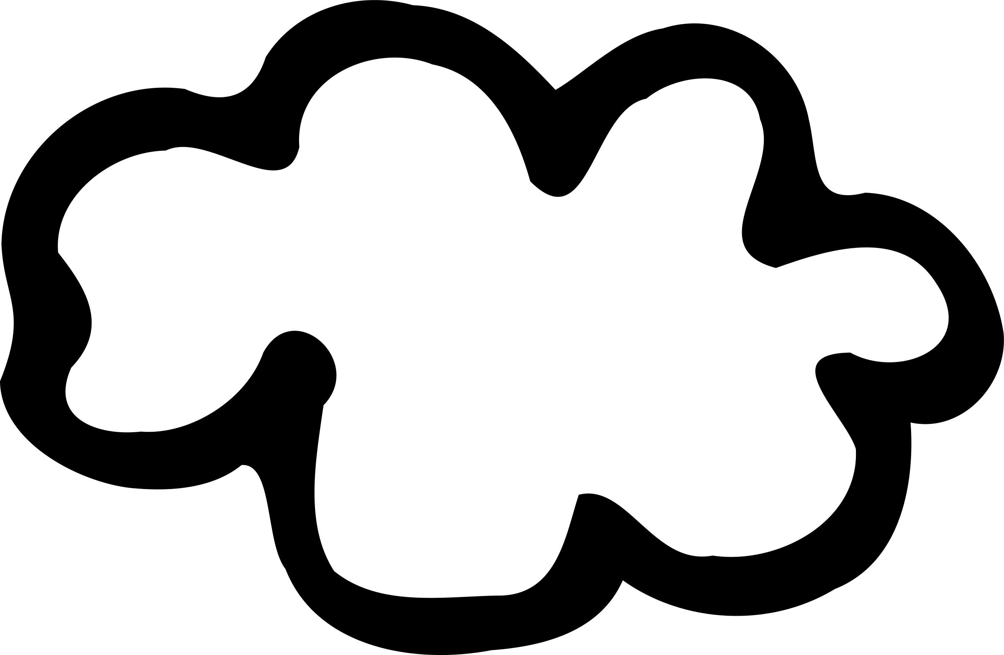
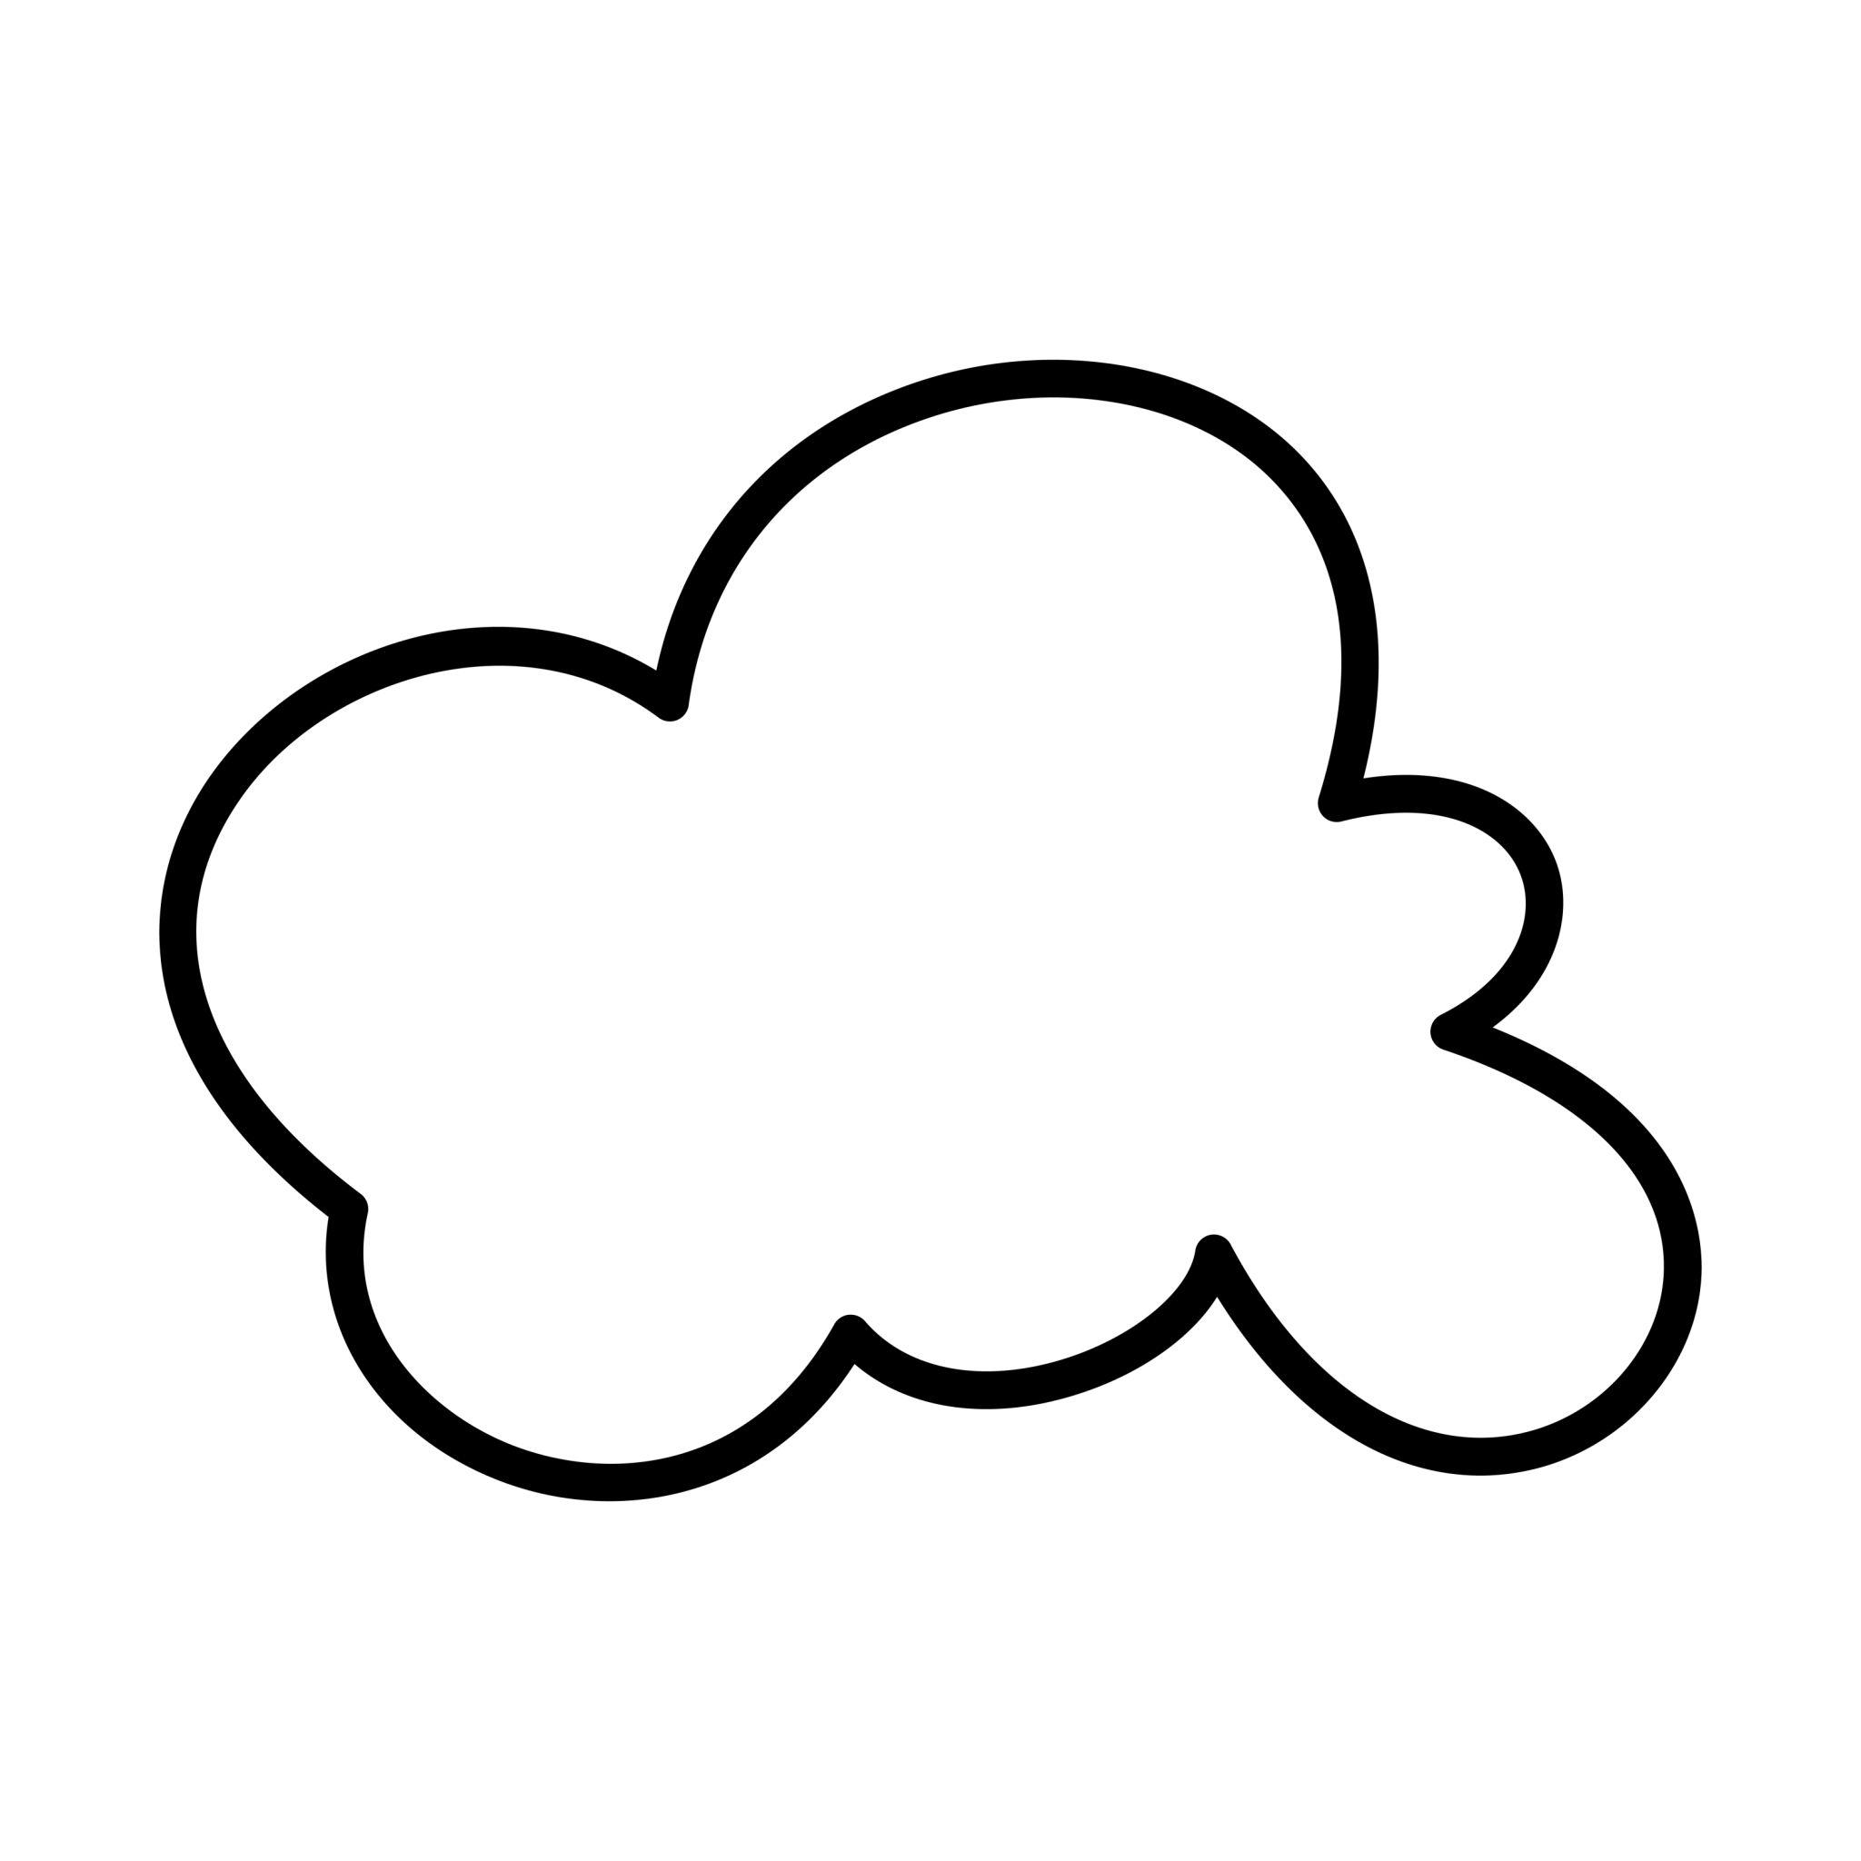
A cloud-like curve may contain several connected curved lobes while remaining one continuous closed boundary.

4. Seed-Like Organic Closed Curves
# Source: AI Source: Provided by: [Data Path: Persons Table -> ID Column: 1, Name_En Column: Motasem Essam] -> From: [ChatGPT] on [7/25/2026]
These resemble seeds, grains, or other naturally occurring small objects.
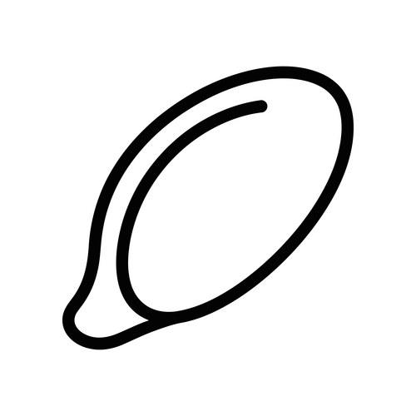
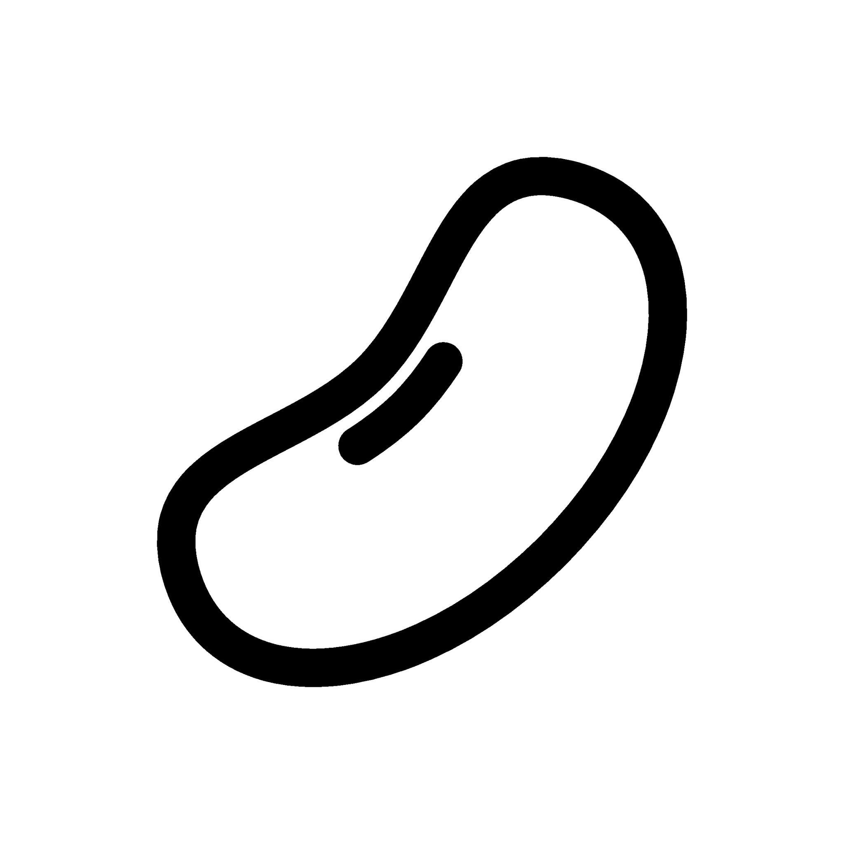
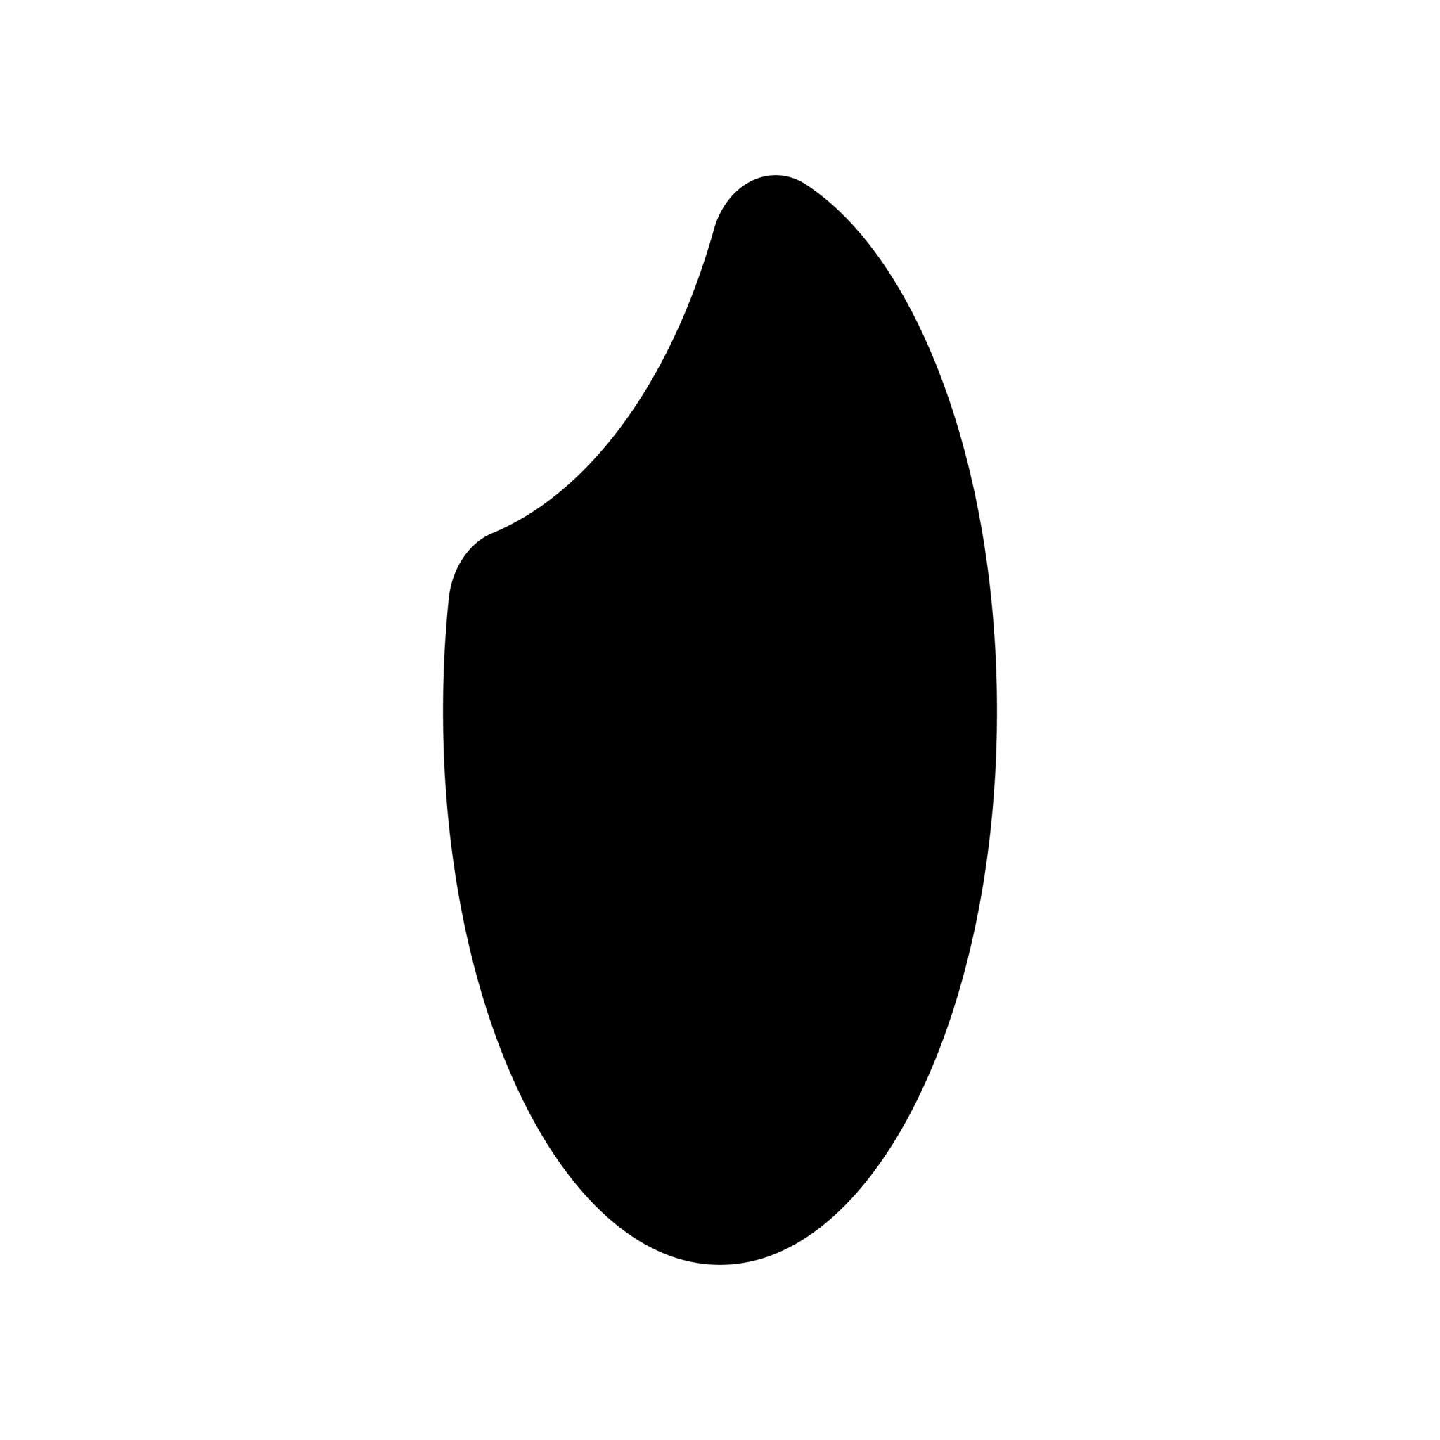
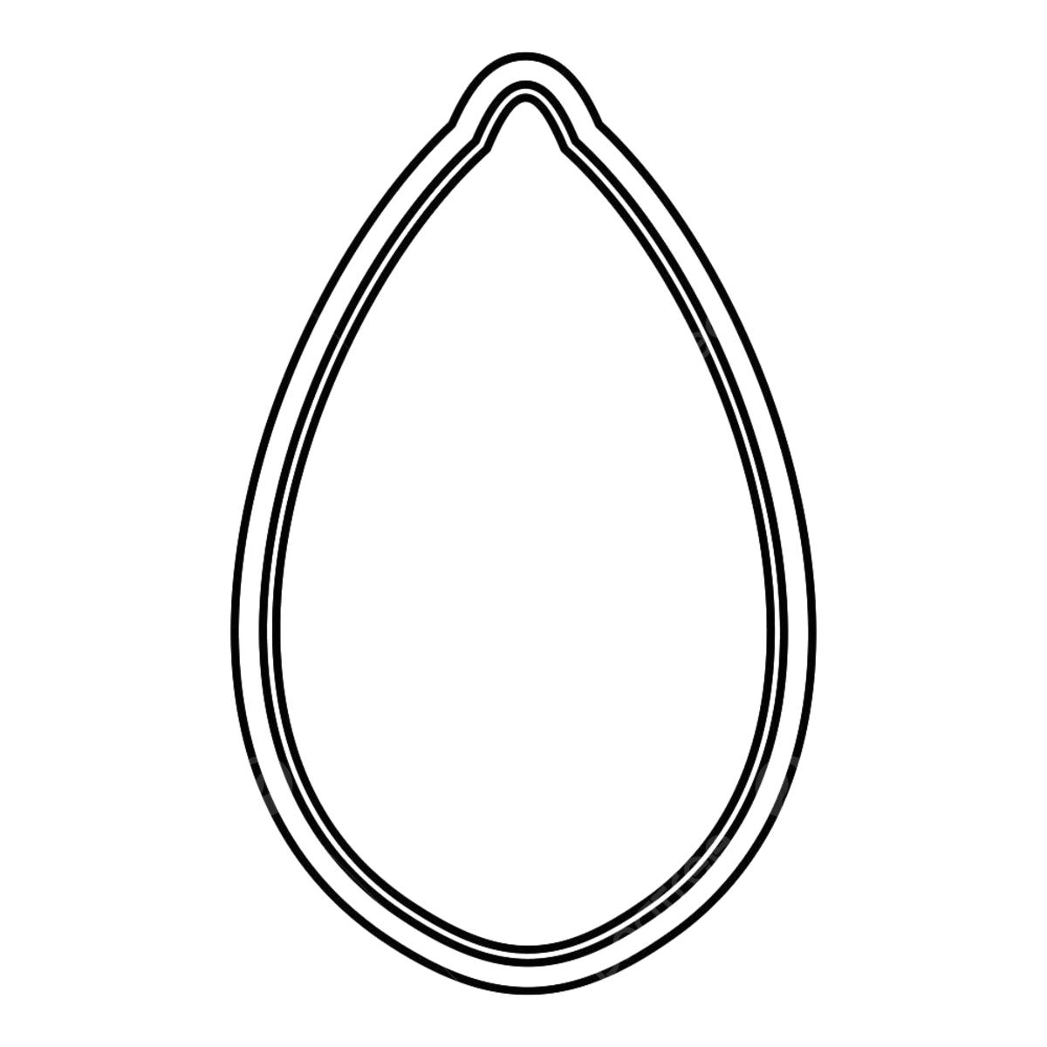
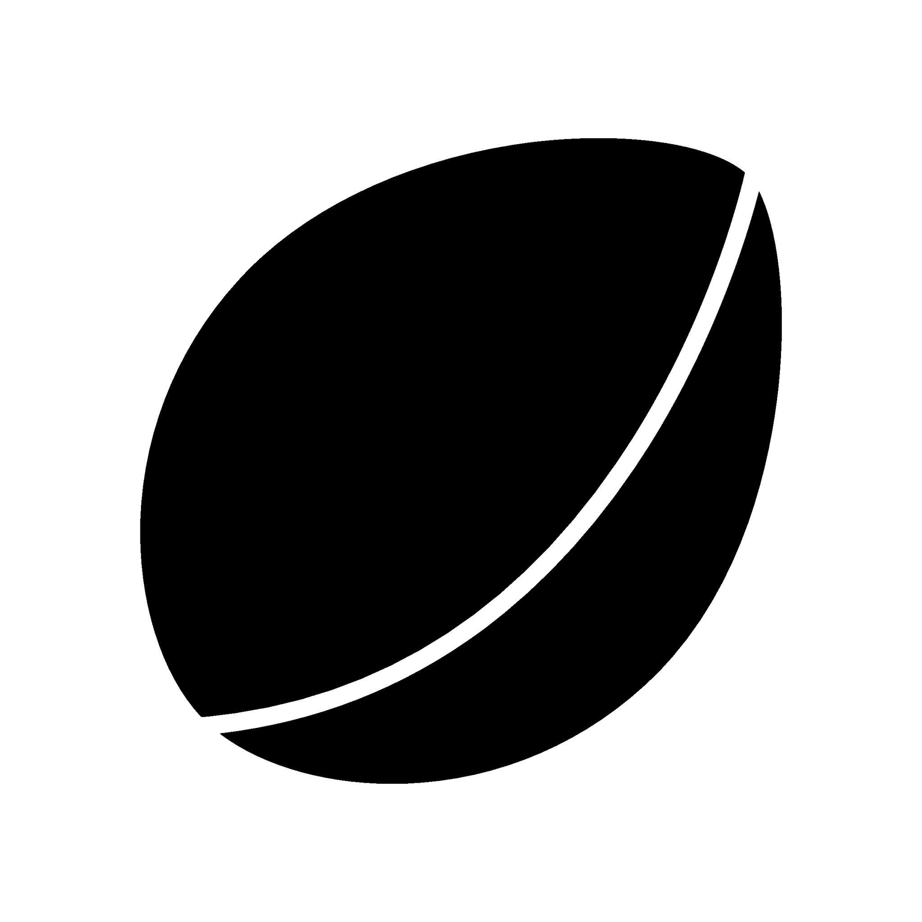
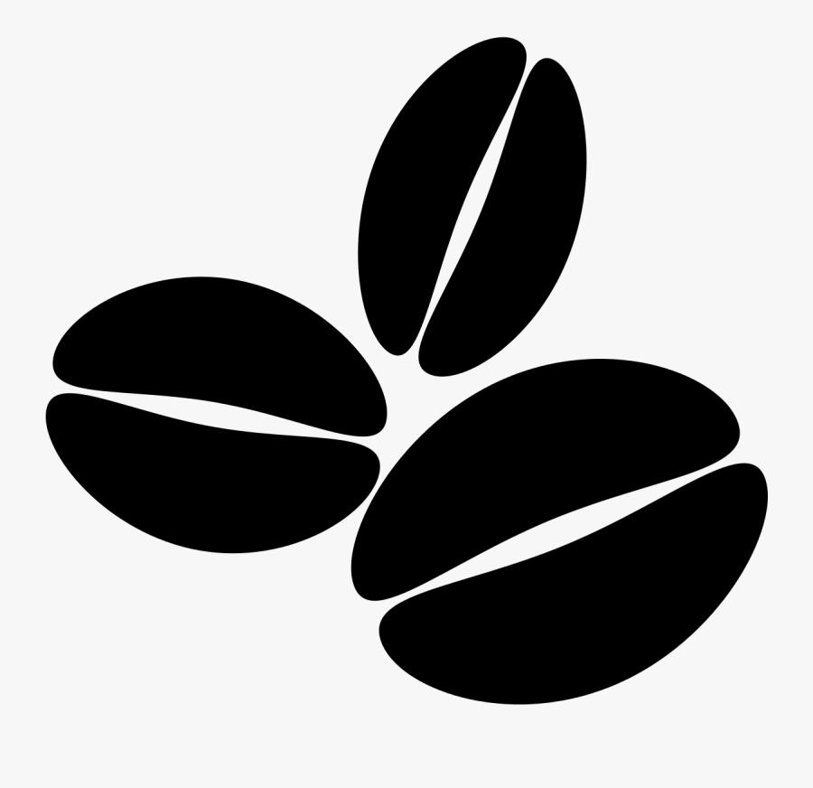
They are often:
- Smooth.
- Rounded.
- Slightly elongated.
- Asymmetric.

5. Cell-Like Organic Closed Curves
# Source: AI Source: Provided by: [Data Path: Persons Table -> ID Column: 1, Name_En Column: Motasem Essam] -> From: [ChatGPT] on [7/25/2026]
These resemble the irregular outlines of biological cells.
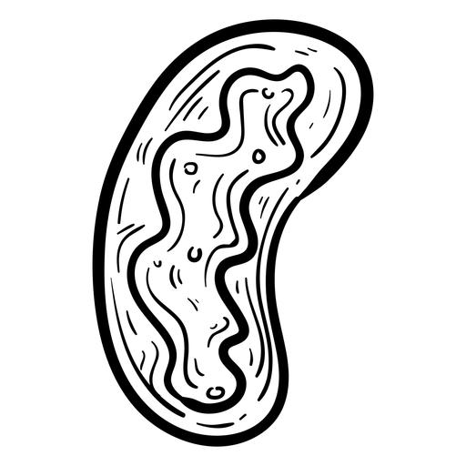
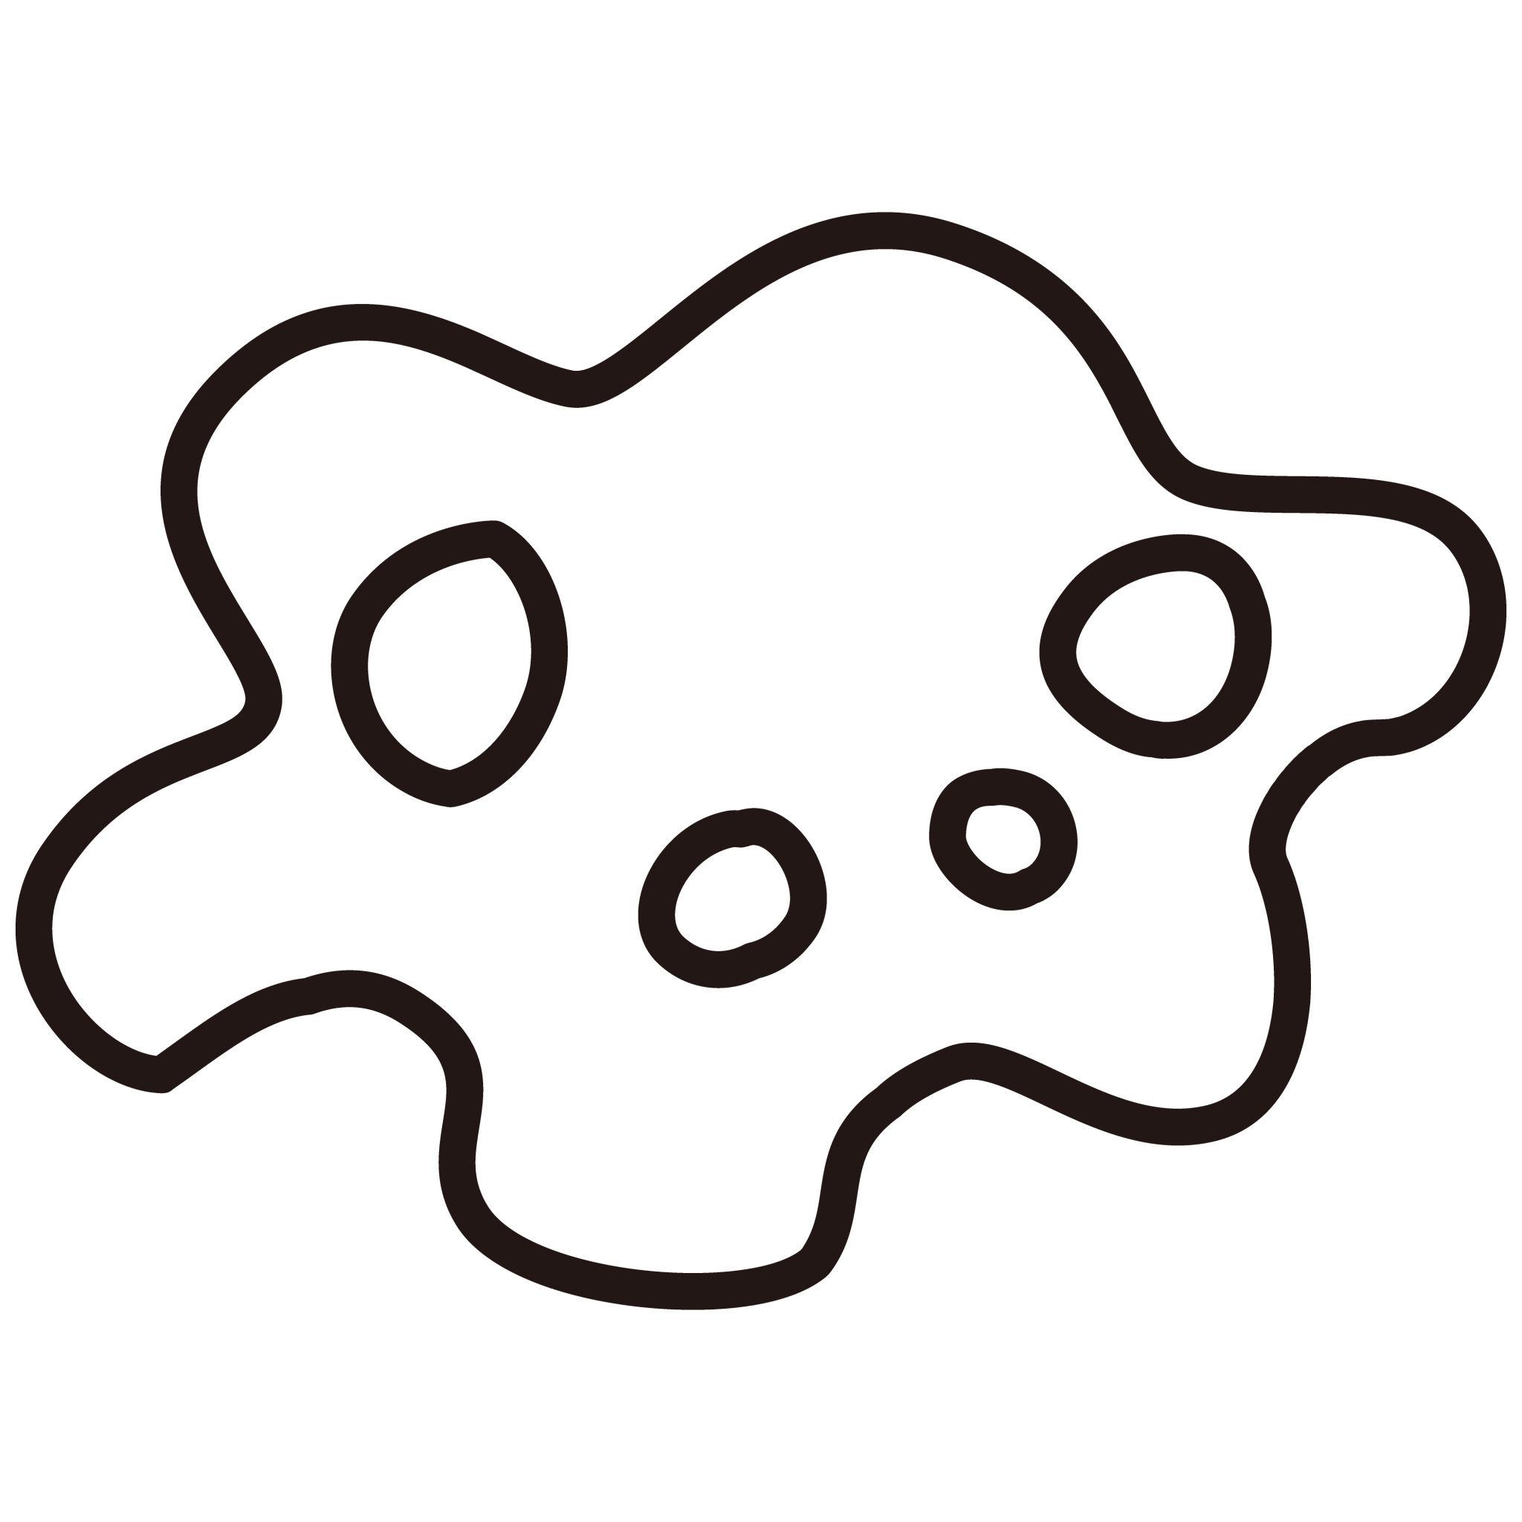
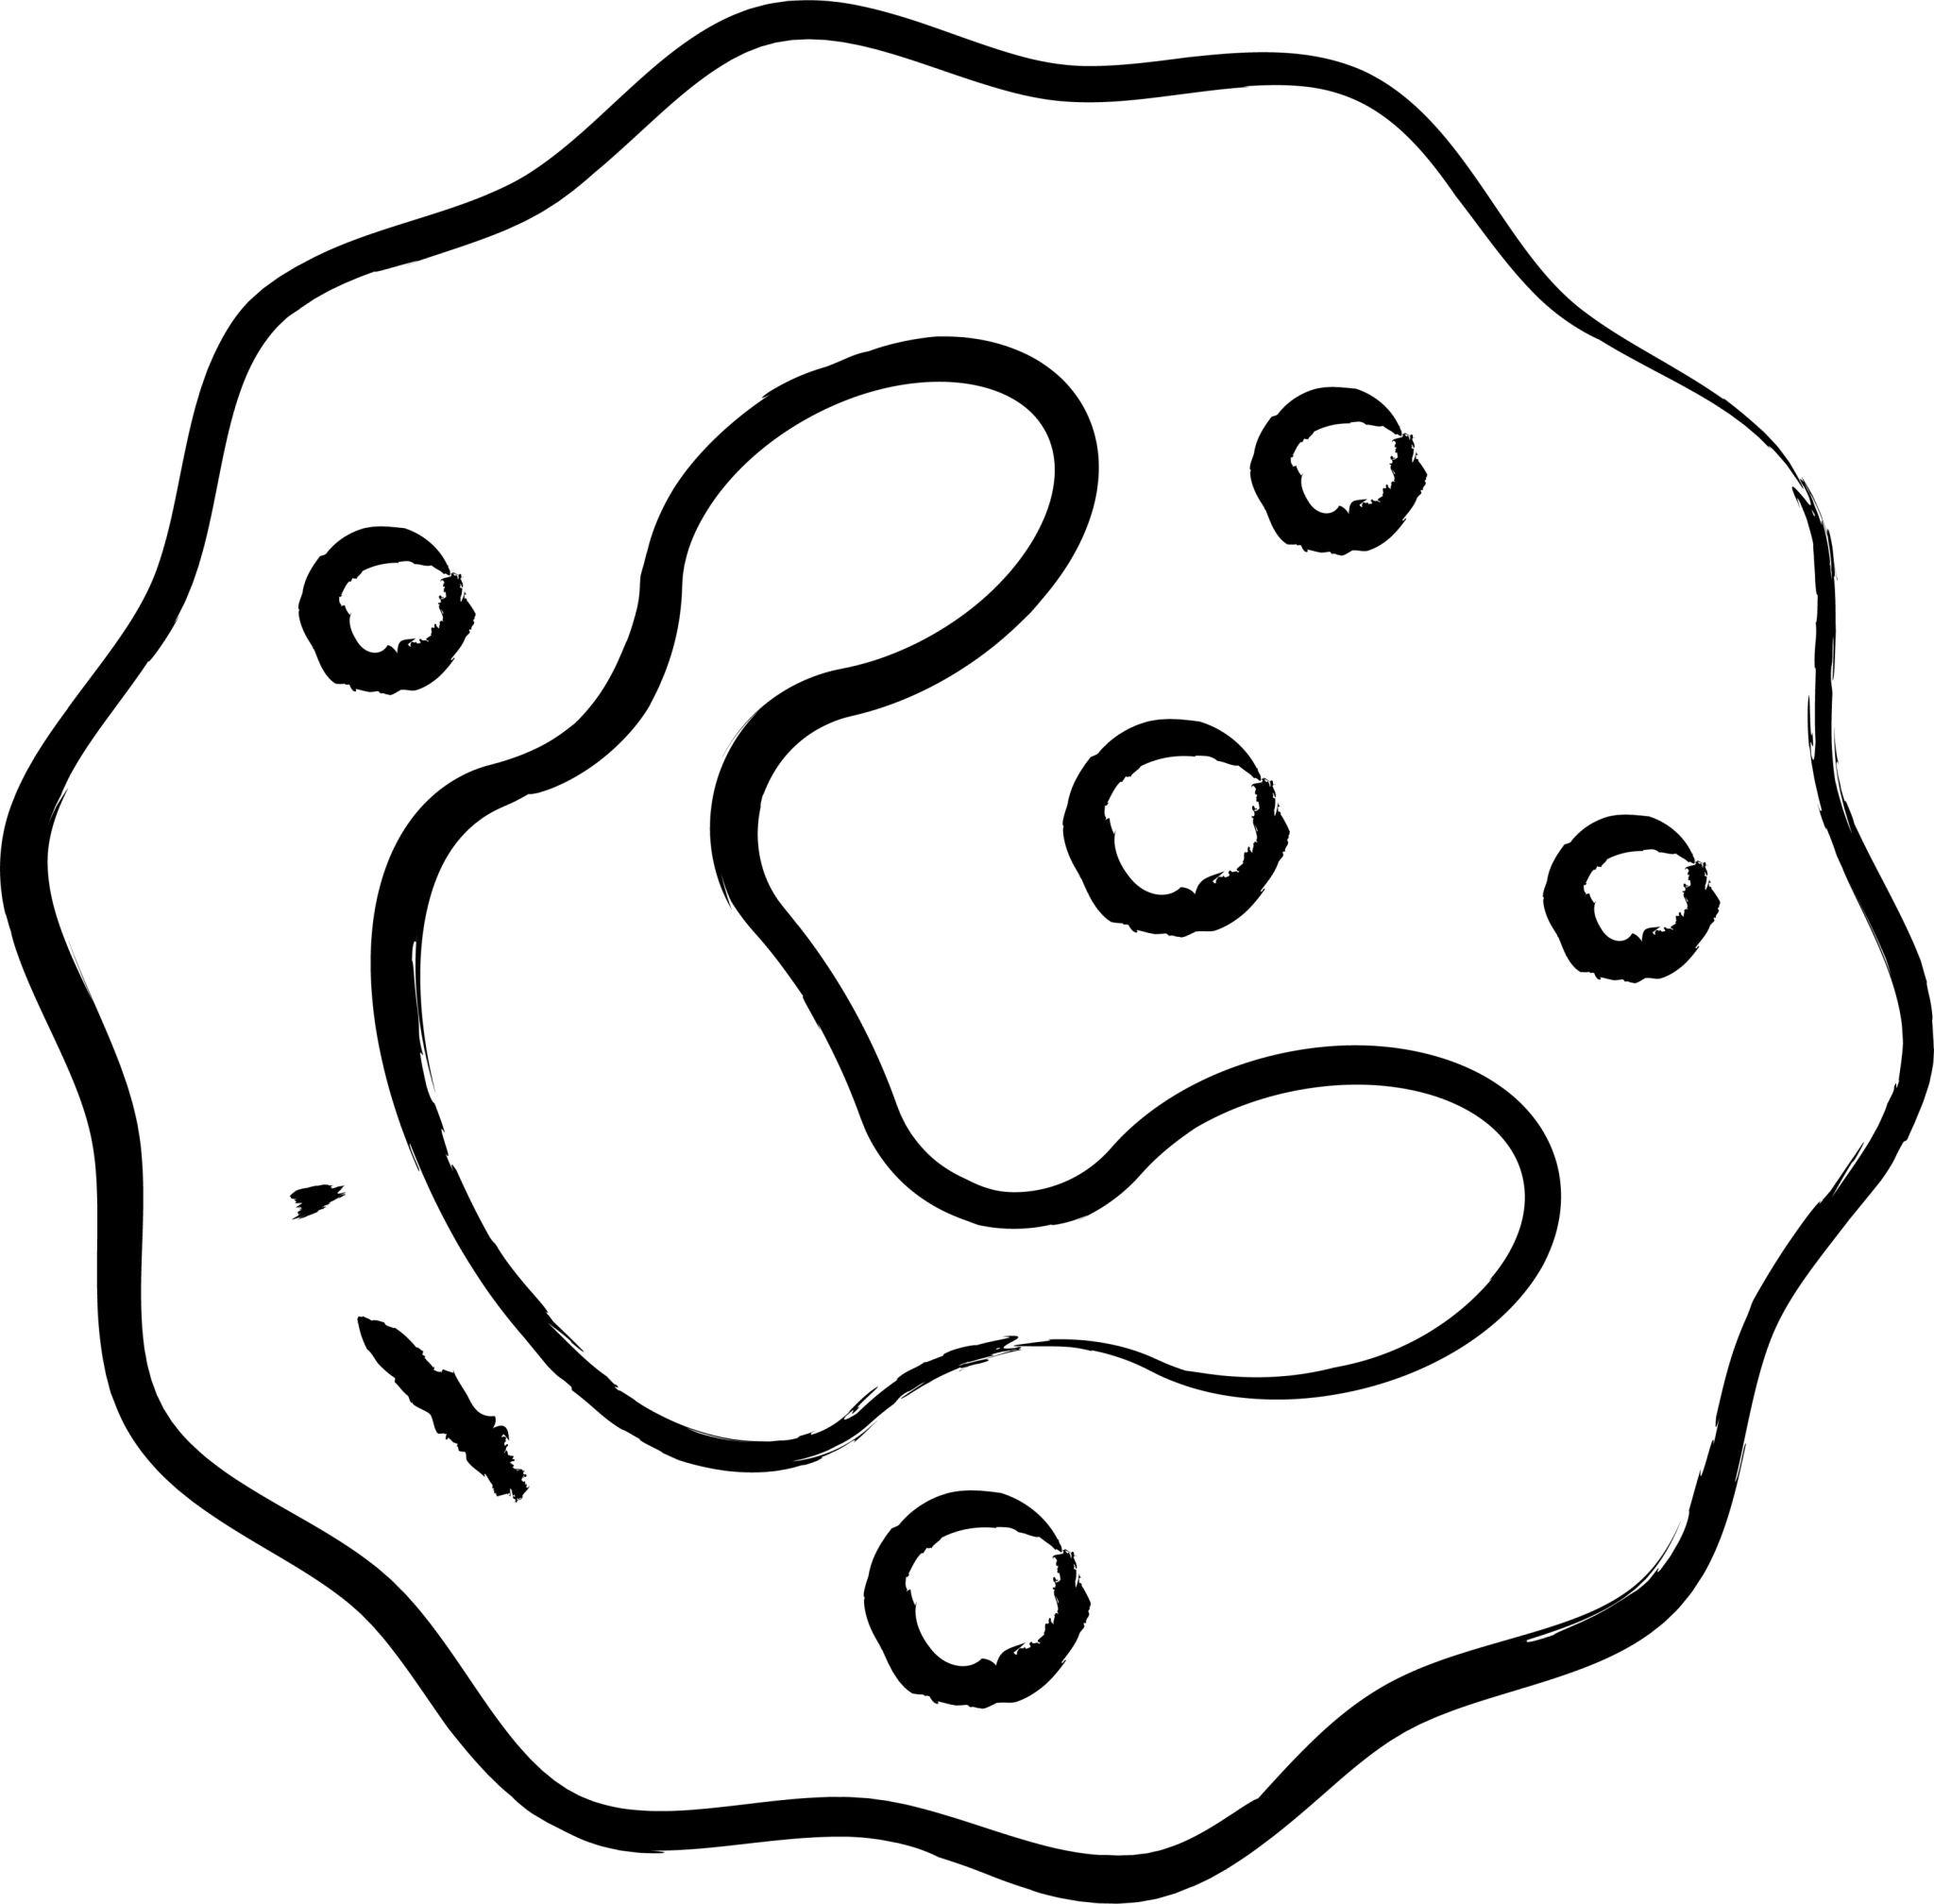
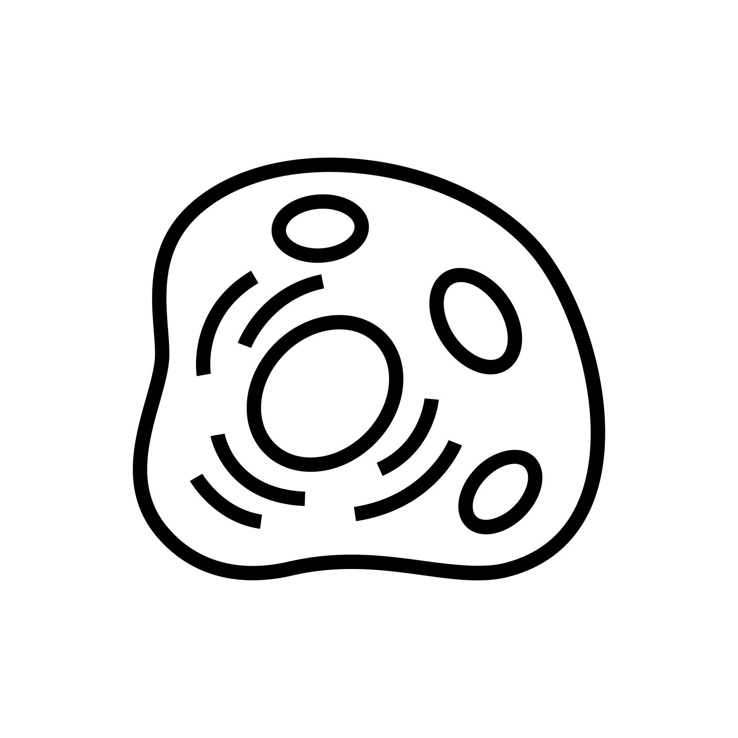
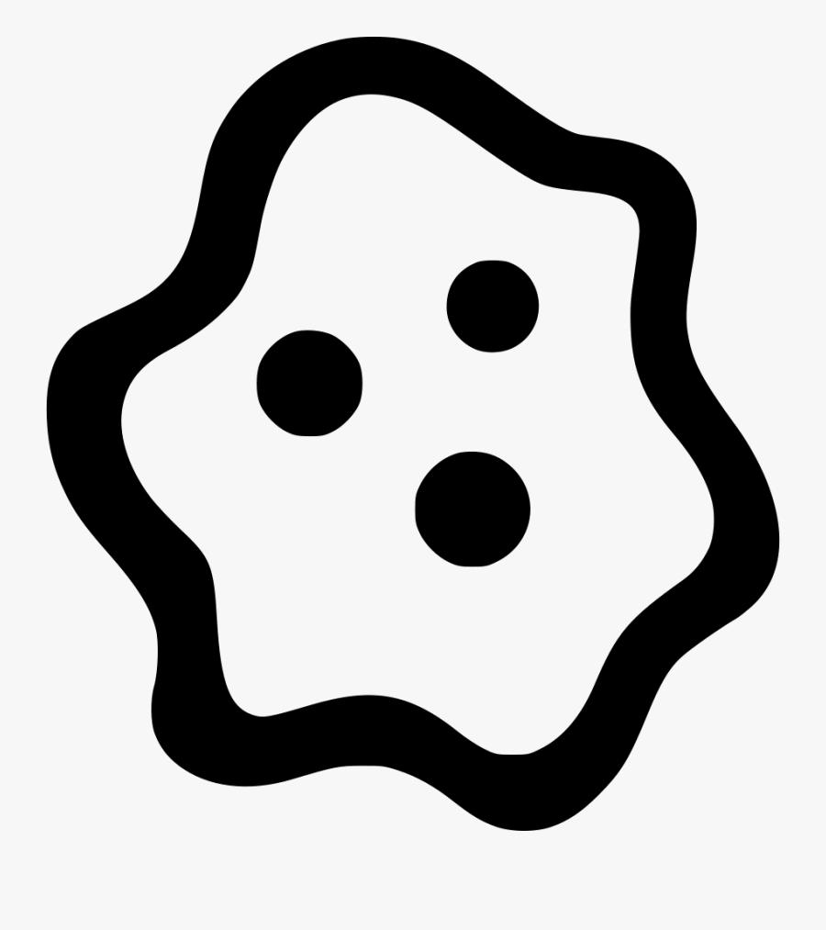
Their boundaries may vary significantly in curvature.
A simplified representation is useful for geometry and biology diagrams, but actual cells can have much more complex boundaries.

6. Droplet-Like Organic Closed Curves
# Source: AI Source: Provided by: [Data Path: Persons Table -> ID Column: 1, Name_En Column: Motasem Essam] -> From: [ChatGPT] on [7/25/2026]
These resemble drops of water, liquid, or other fluid forms.
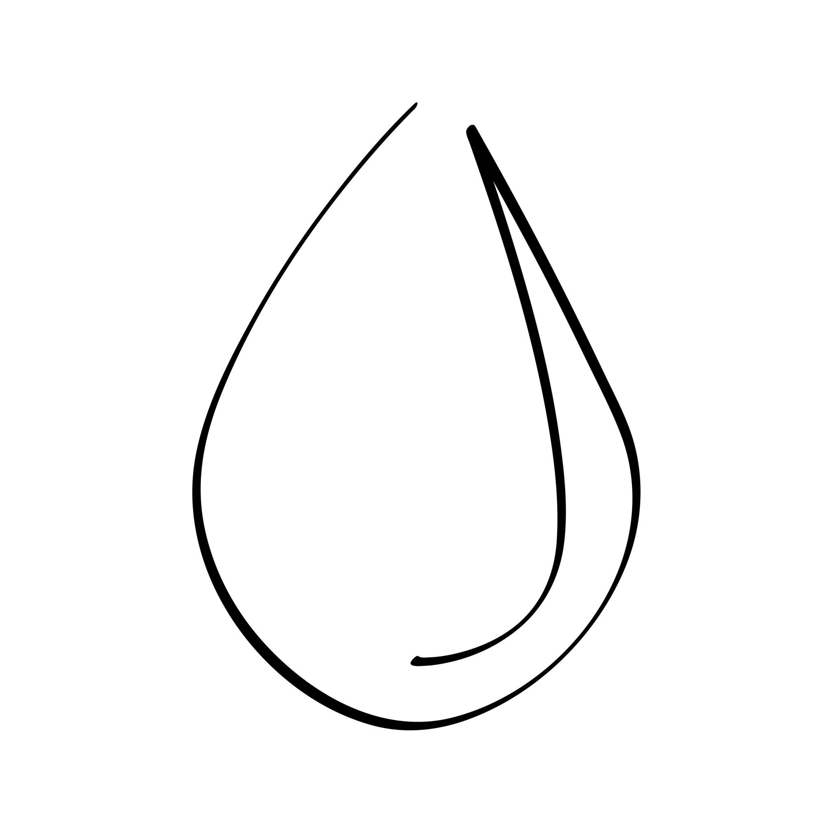
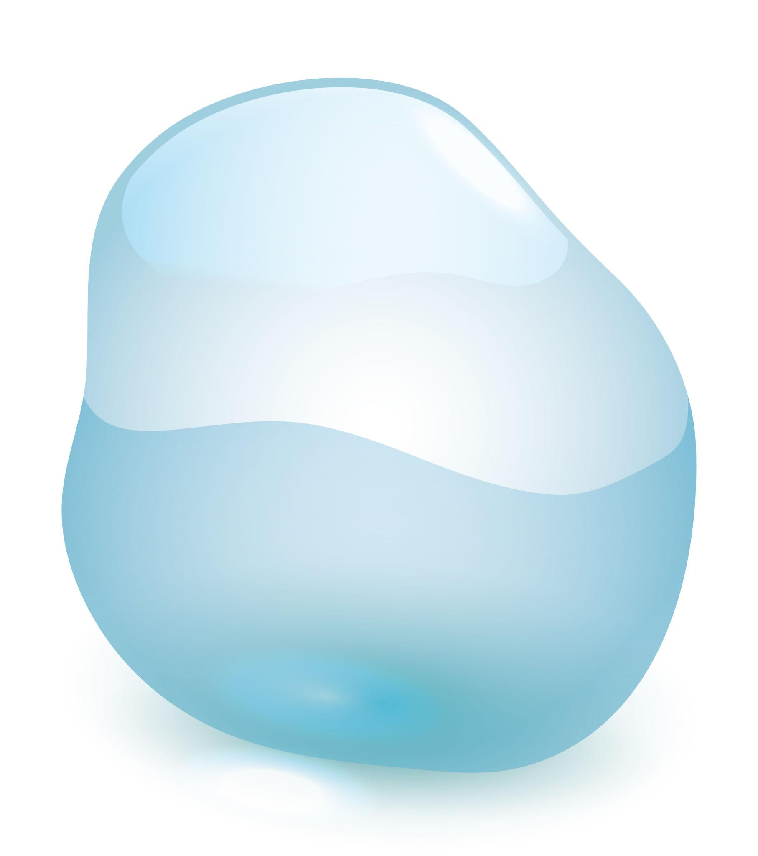
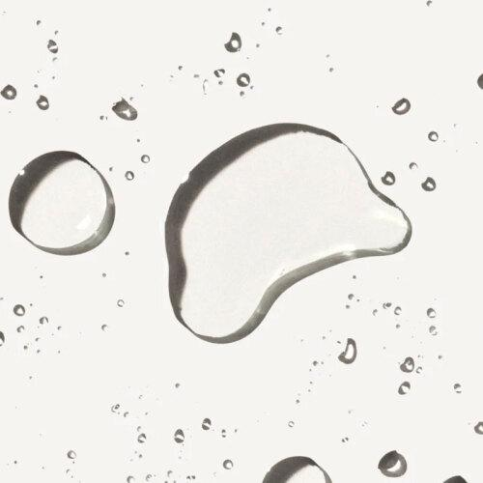
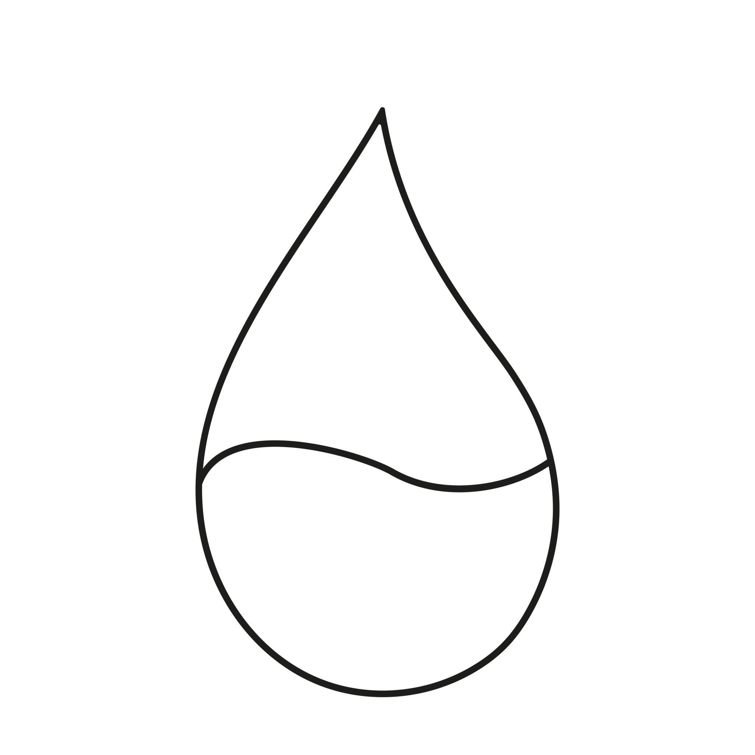
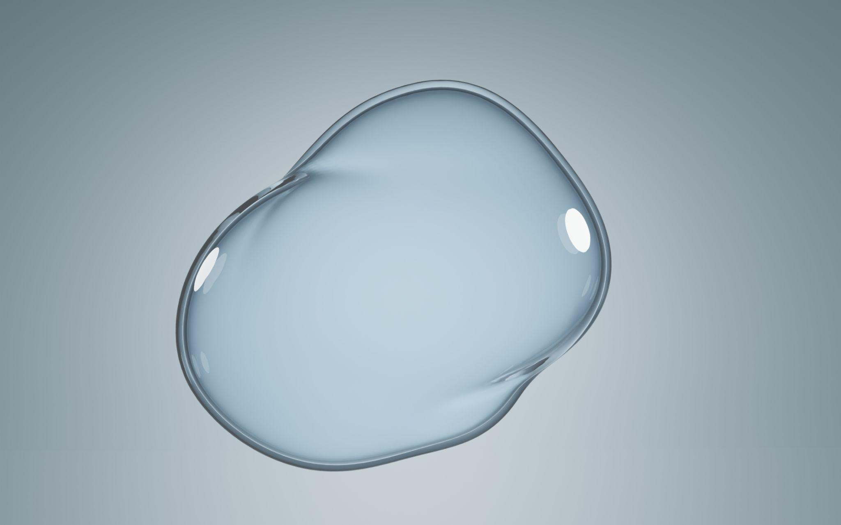
They can have:
- One pointed end.
- One rounded end.
- Smooth variable curvature.
- Asymmetry.

7. Puddle-Like Organic Closed Curves
# Source: AI Source: Provided by: [Data Path: Persons Table -> ID Column: 1, Name_En Column: Motasem Essam] -> From: [ChatGPT] on [7/25/2026]
These represent irregular boundaries of spilled or naturally distributed liquids.
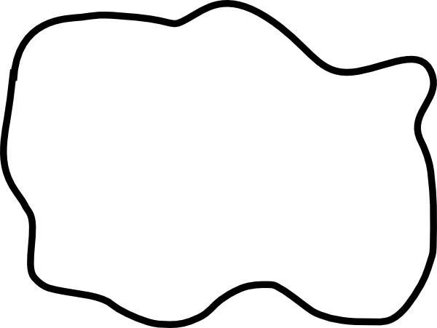
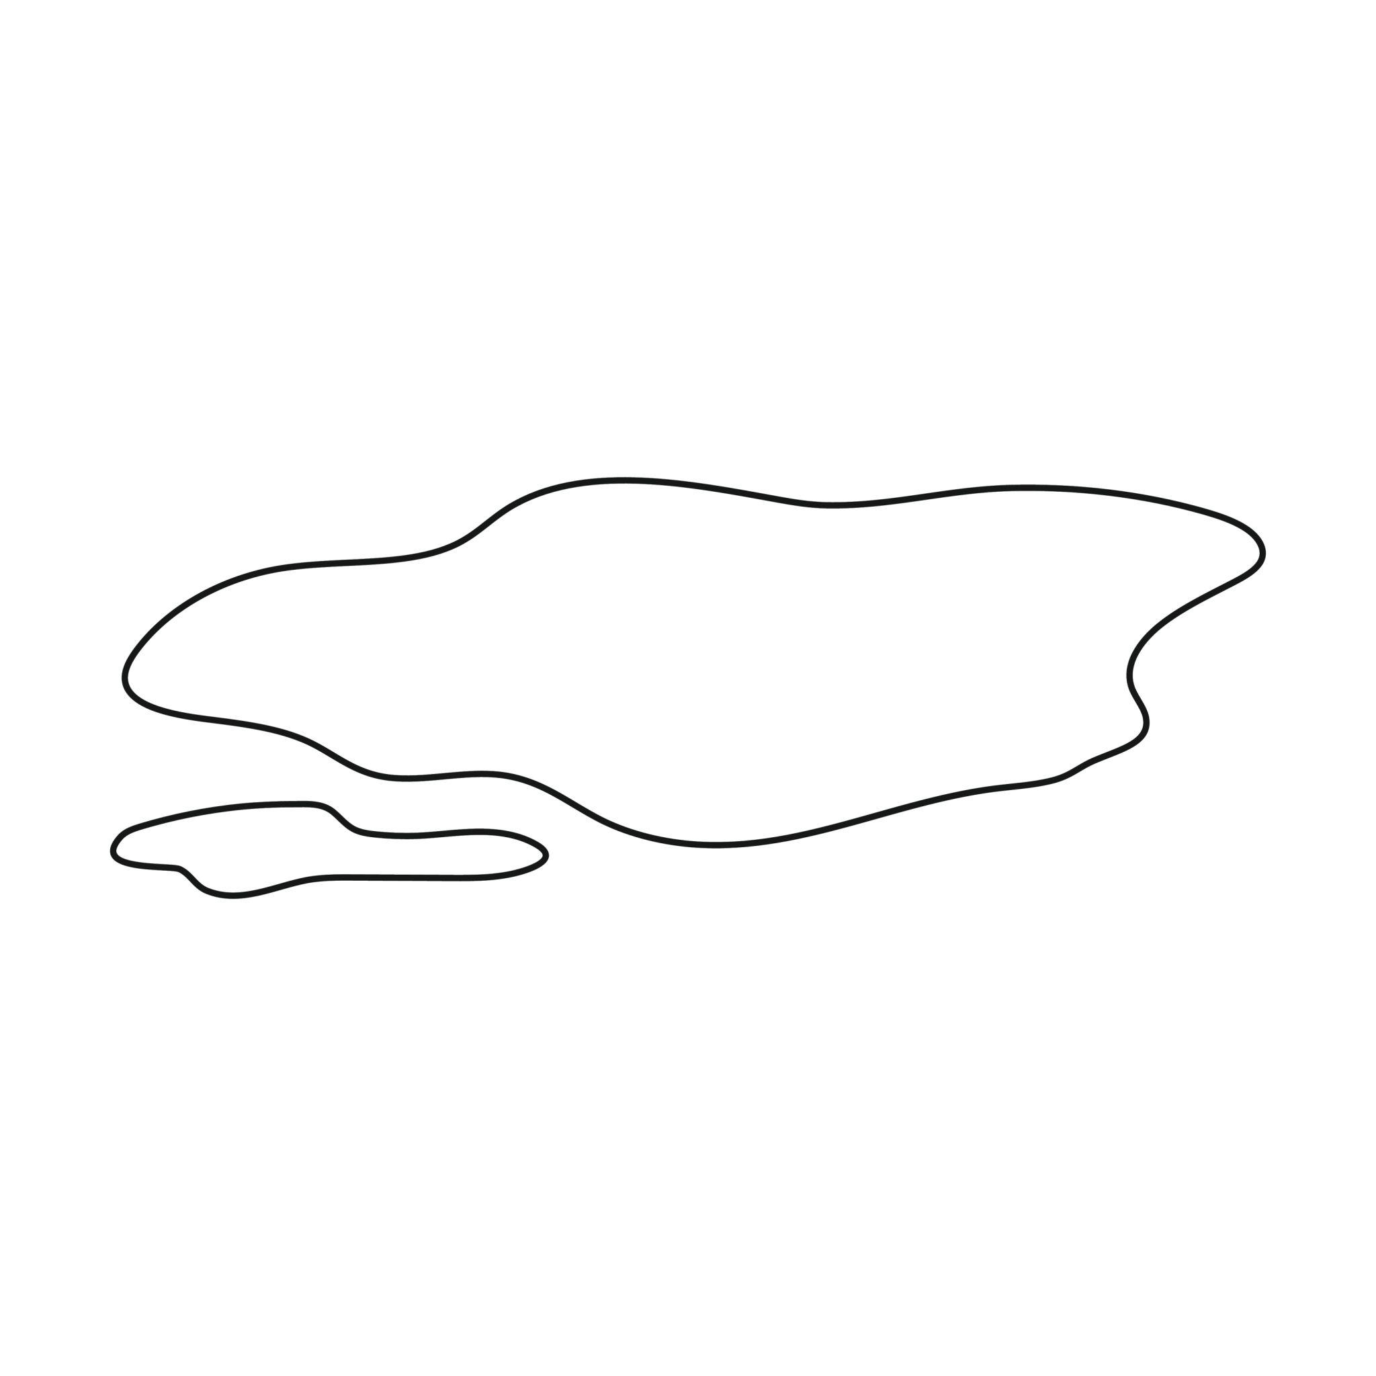
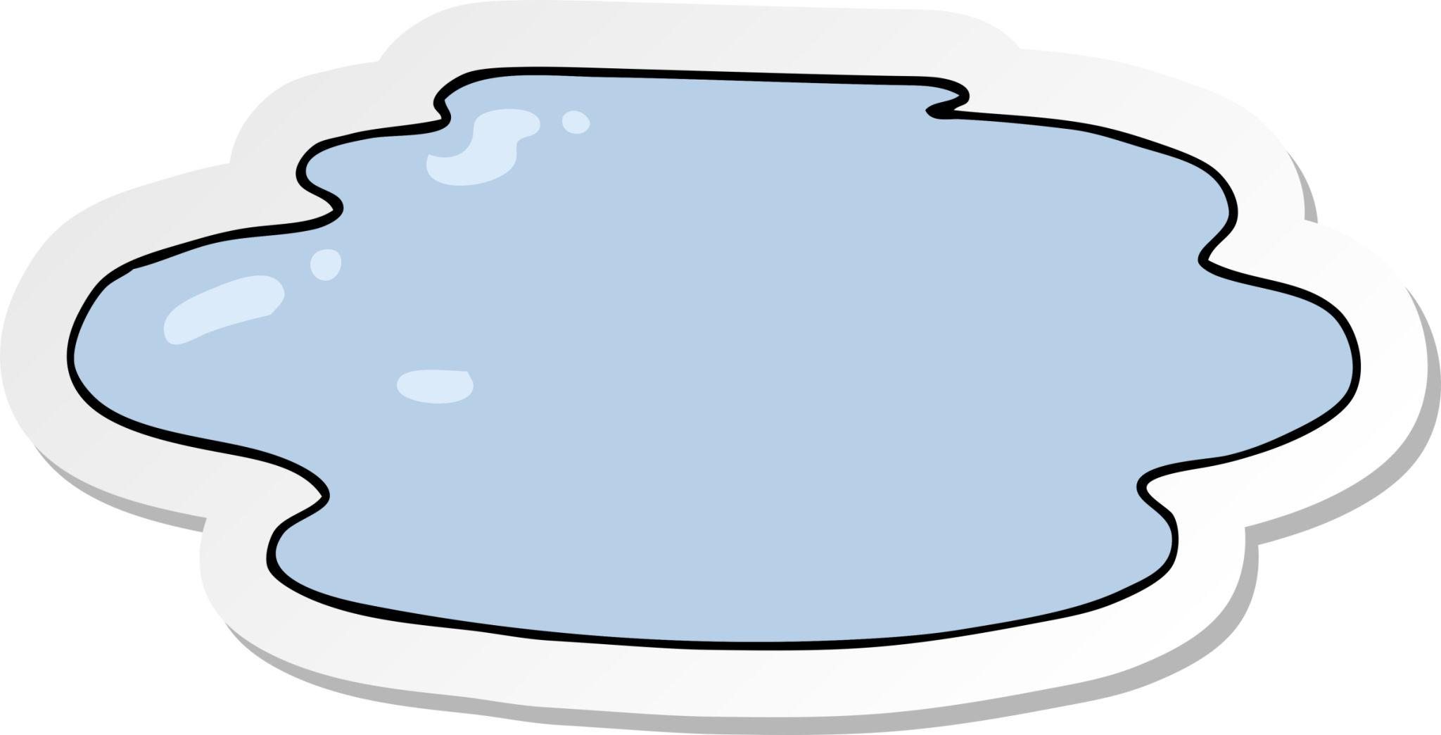
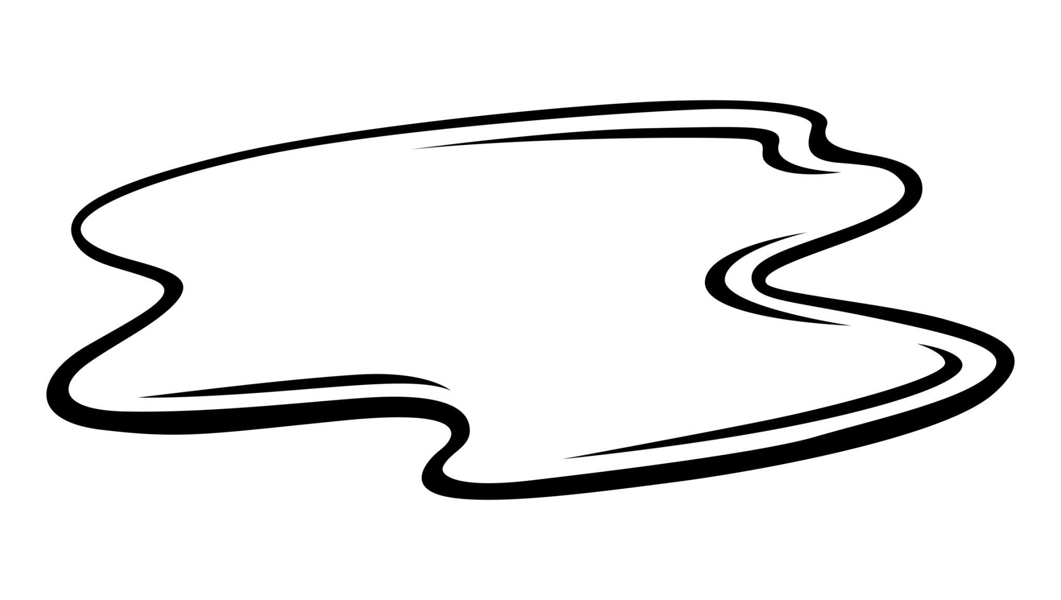
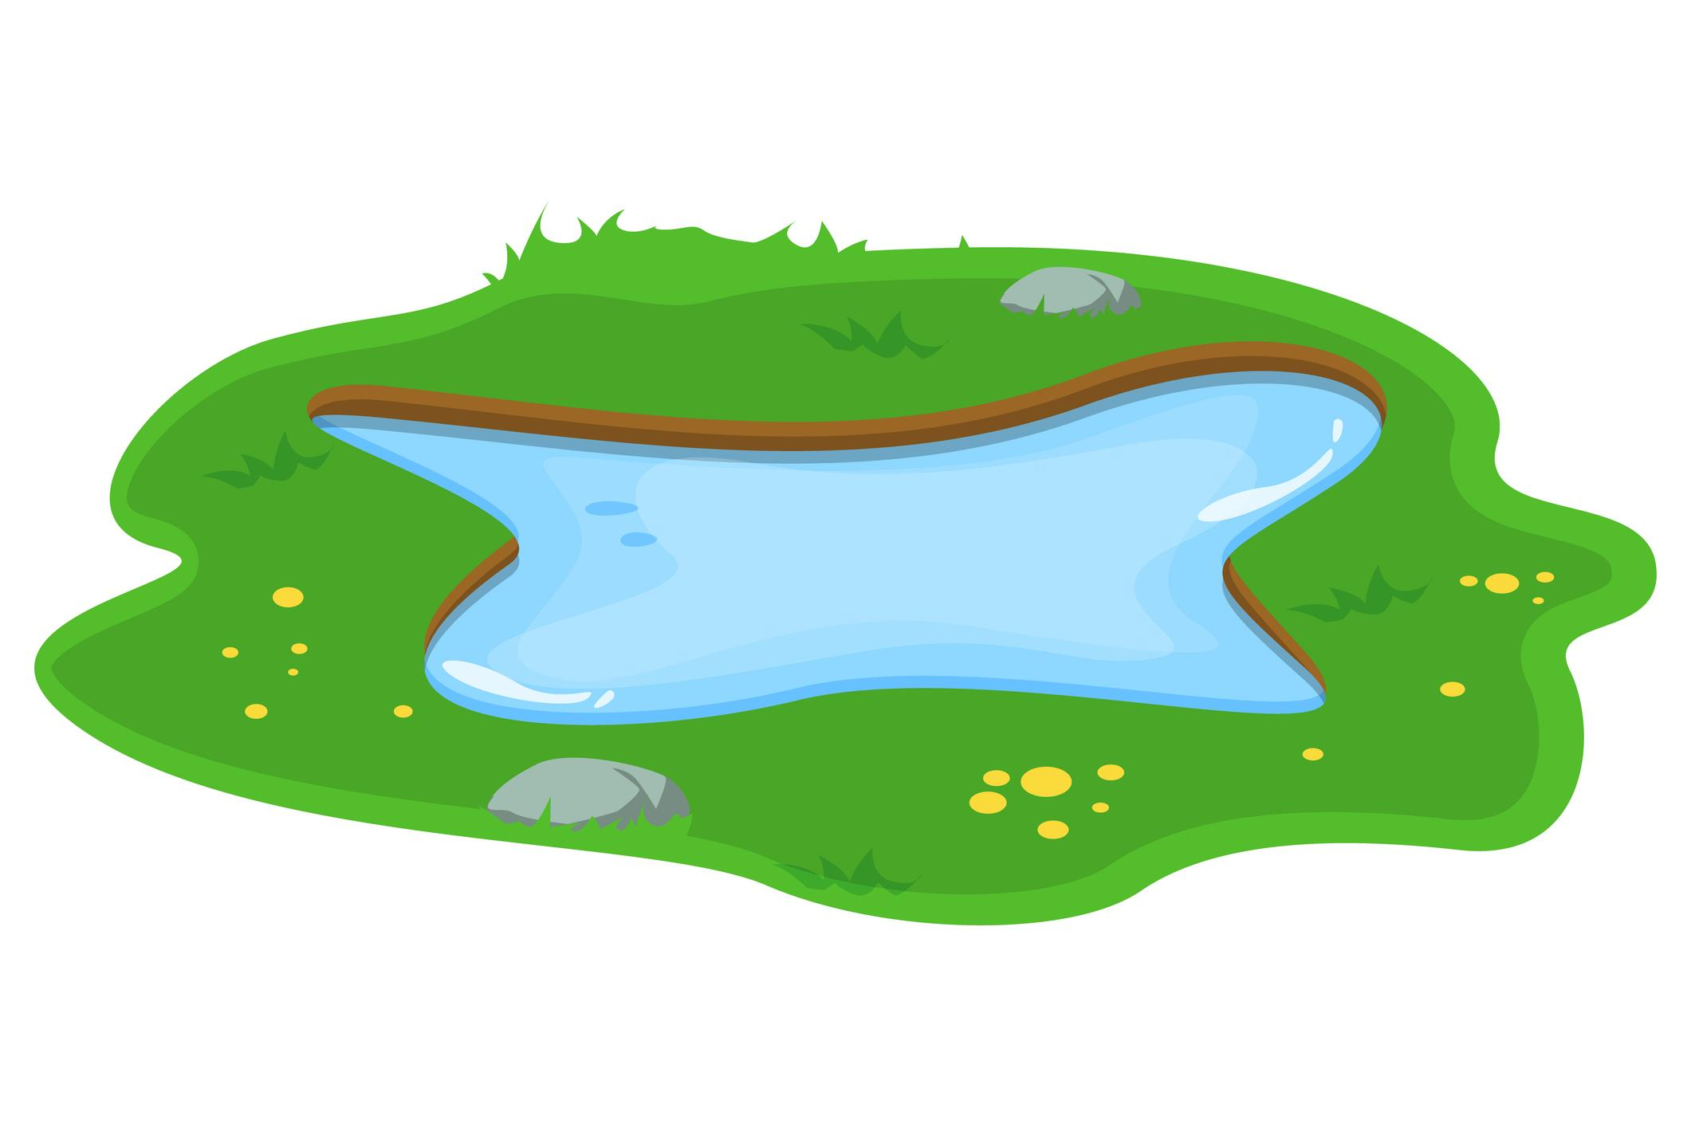
They are typically highly irregular but remain closed.

8. Body-Outline Organic Closed Curves
# Source: AI Source: Provided by: [Data Path: Persons Table -> ID Column: 1, Name_En Column: Motasem Essam] -> From: [ChatGPT] on [7/25/2026]
These are smooth closed outlines resembling natural body parts or biological forms.
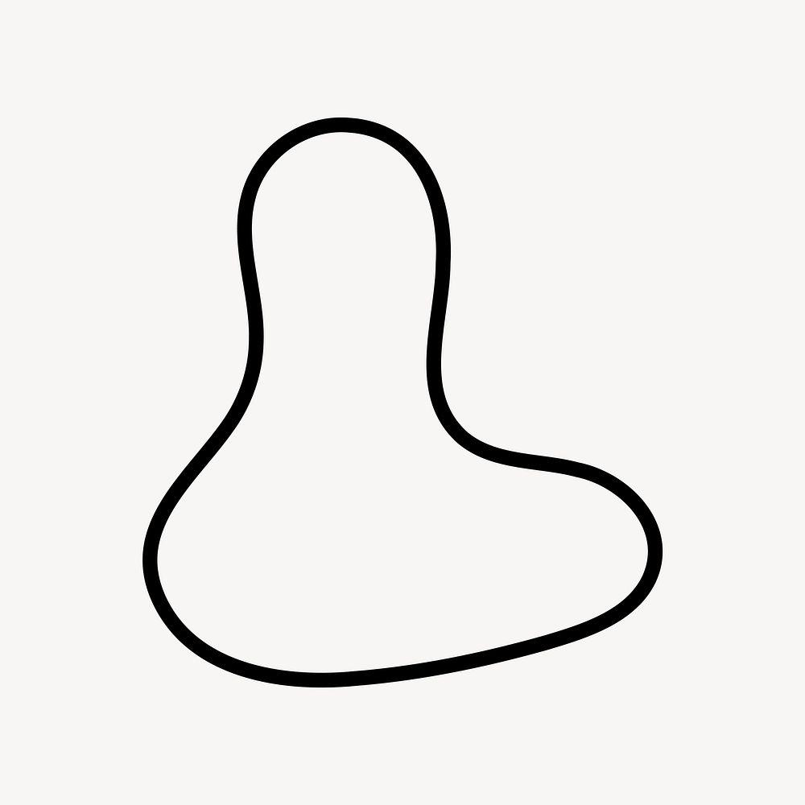
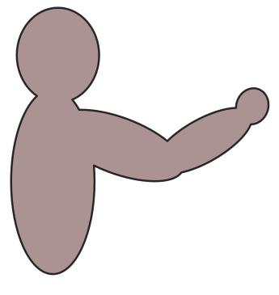
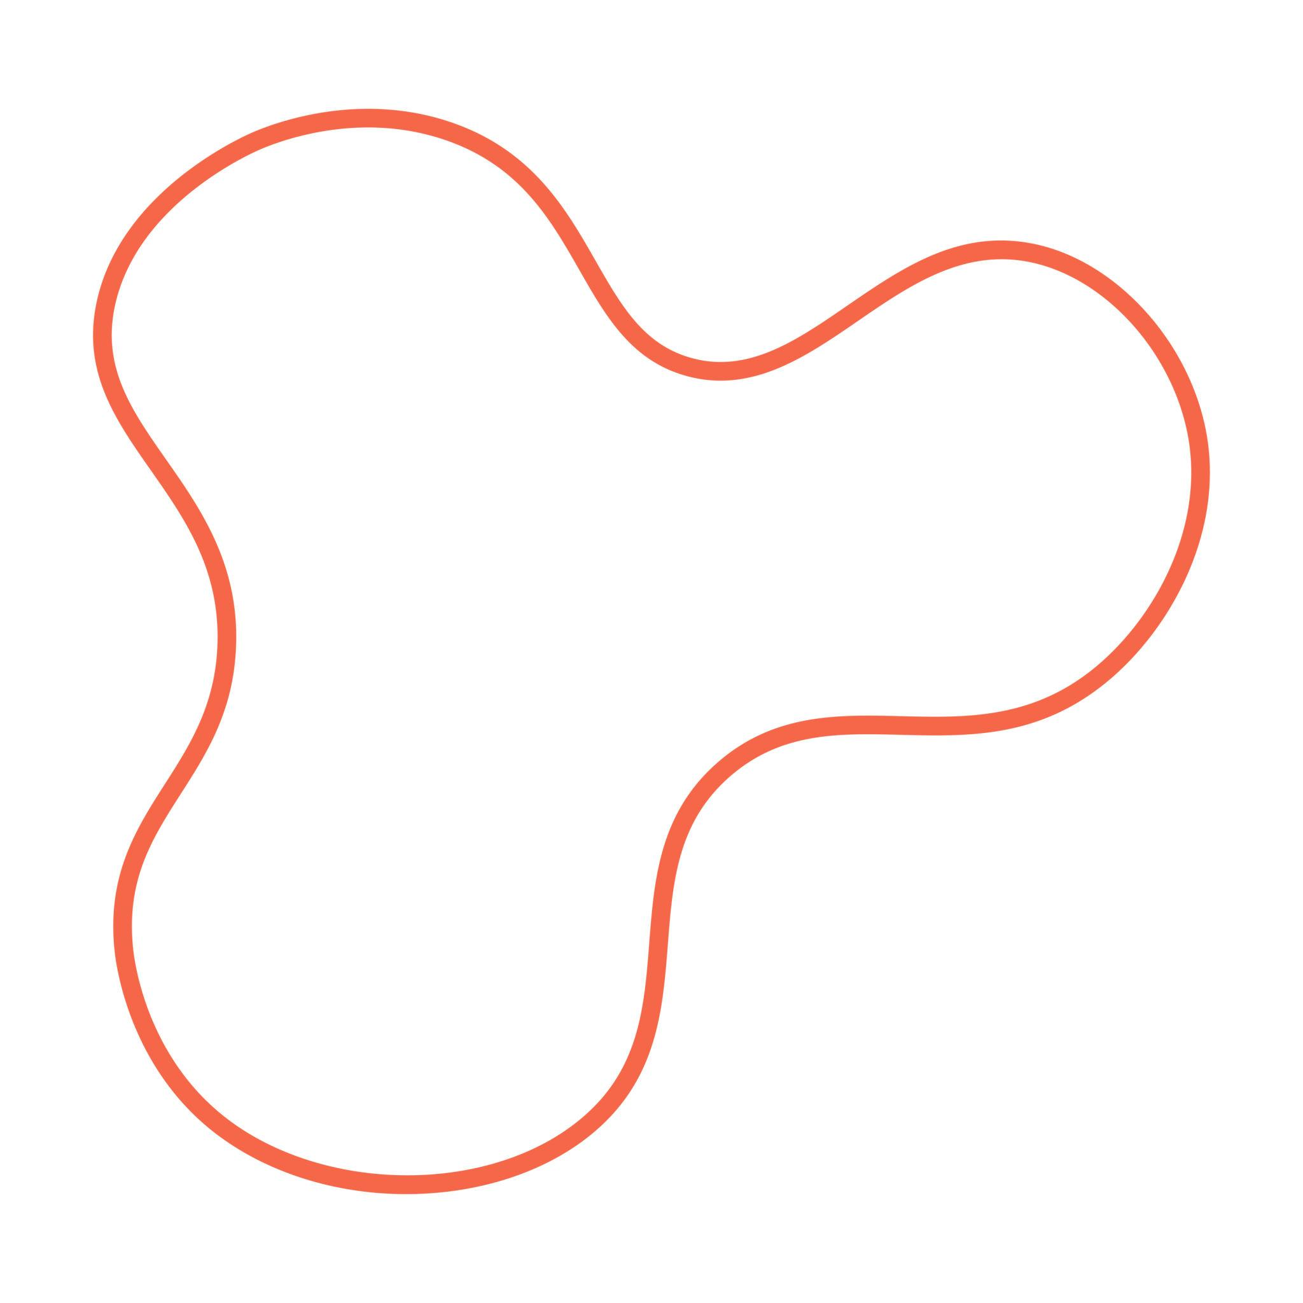
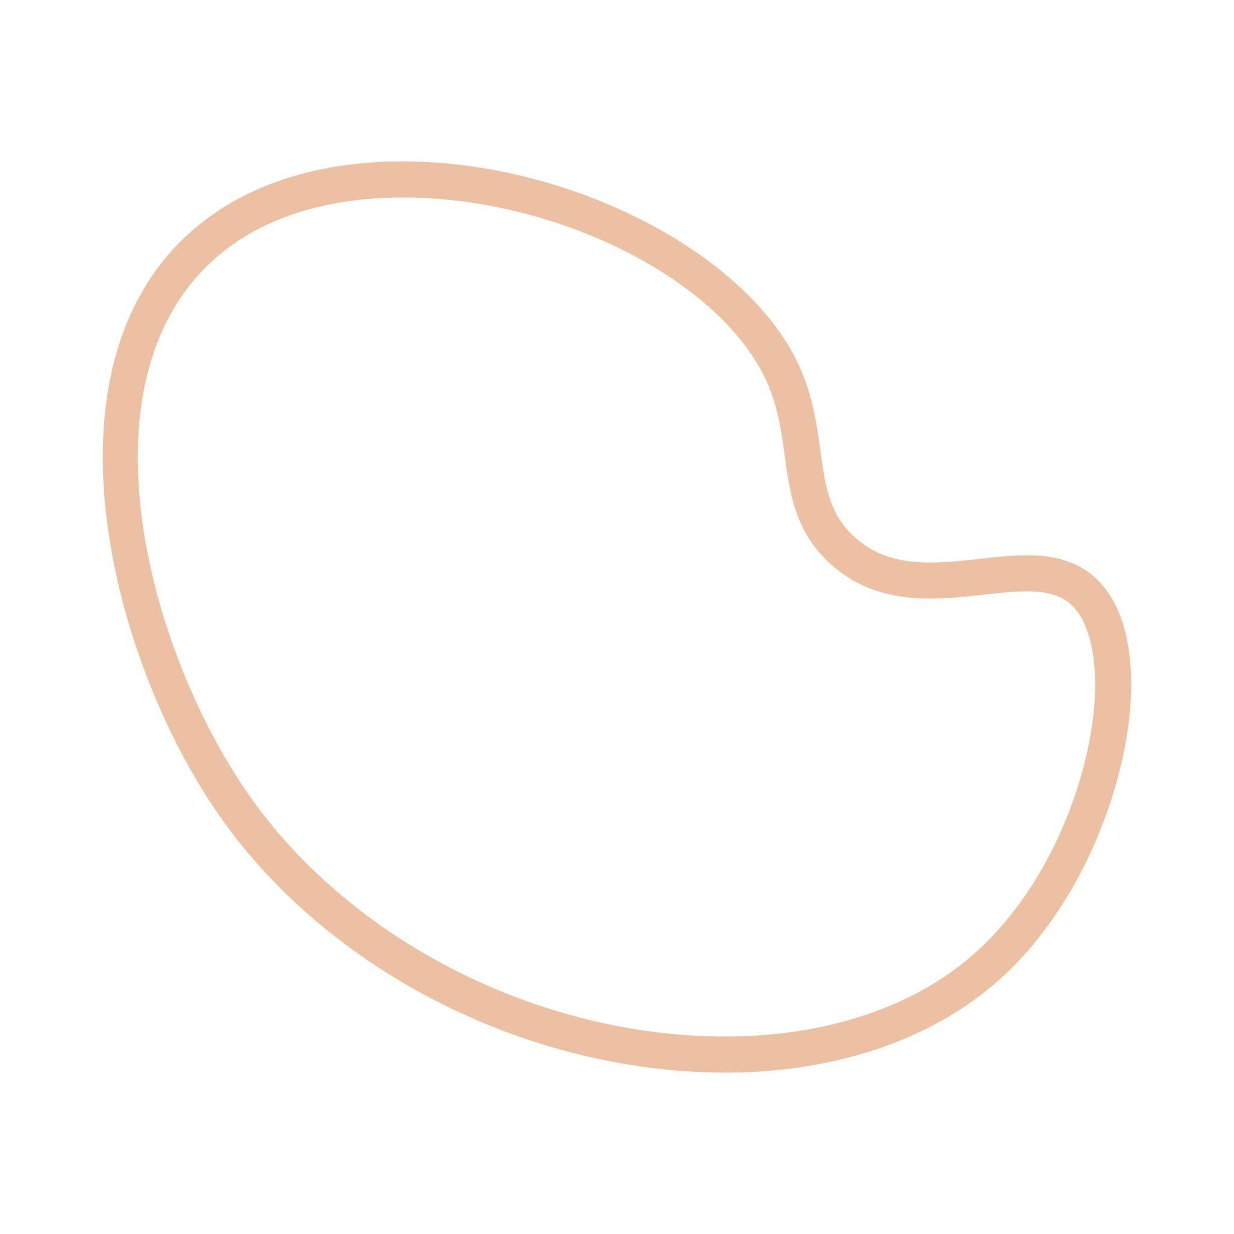
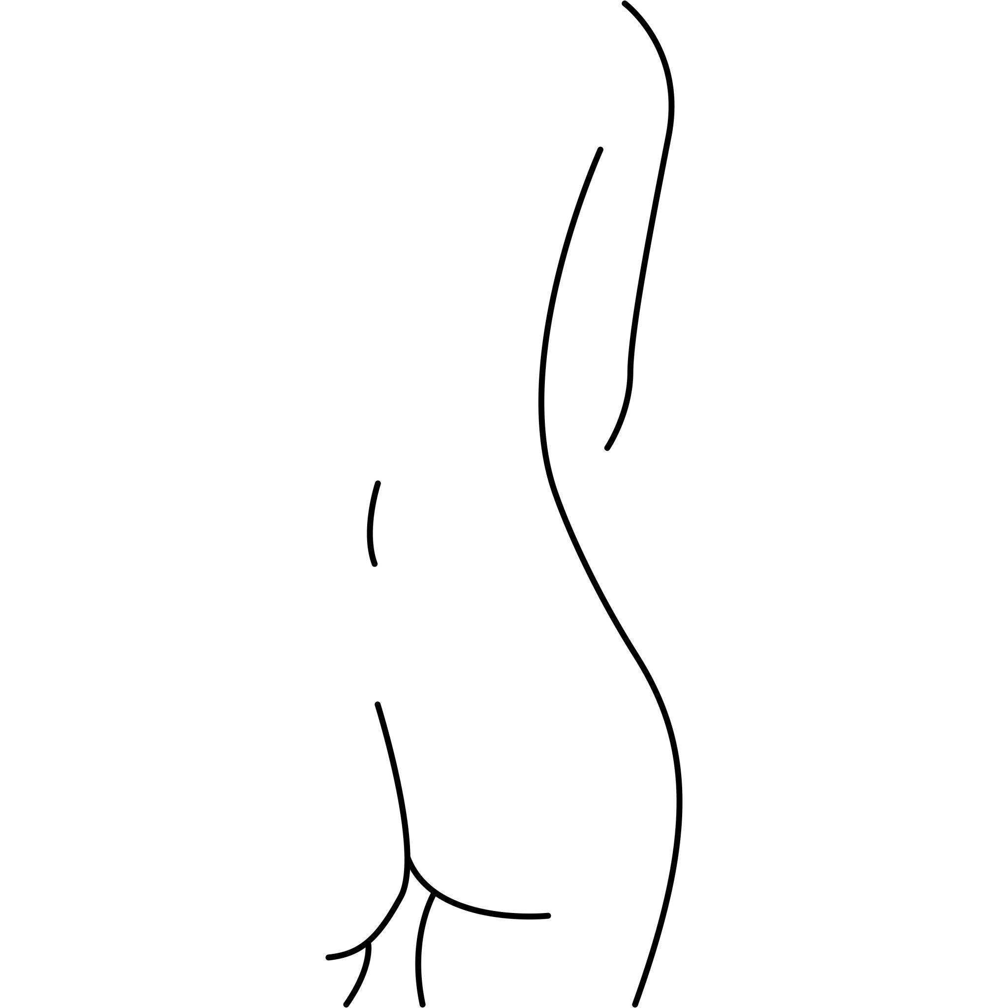
They are often asymmetric and contain smoothly changing curvature.

9. Floral / Petal-Like Organic Closed Curves
# Source: AI Source: Provided by: [Data Path: Persons Table -> ID Column: 1, Name_En Column: Motasem Essam] -> From: [ChatGPT] on [7/25/2026]
These resemble individual petals or flower-like outlines.
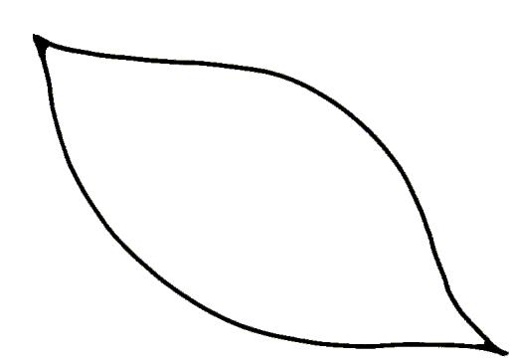
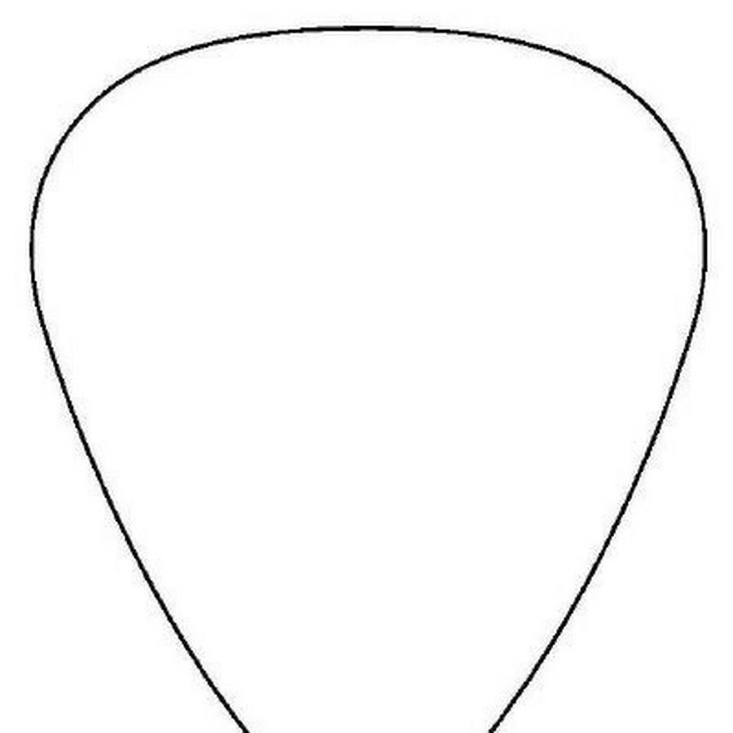
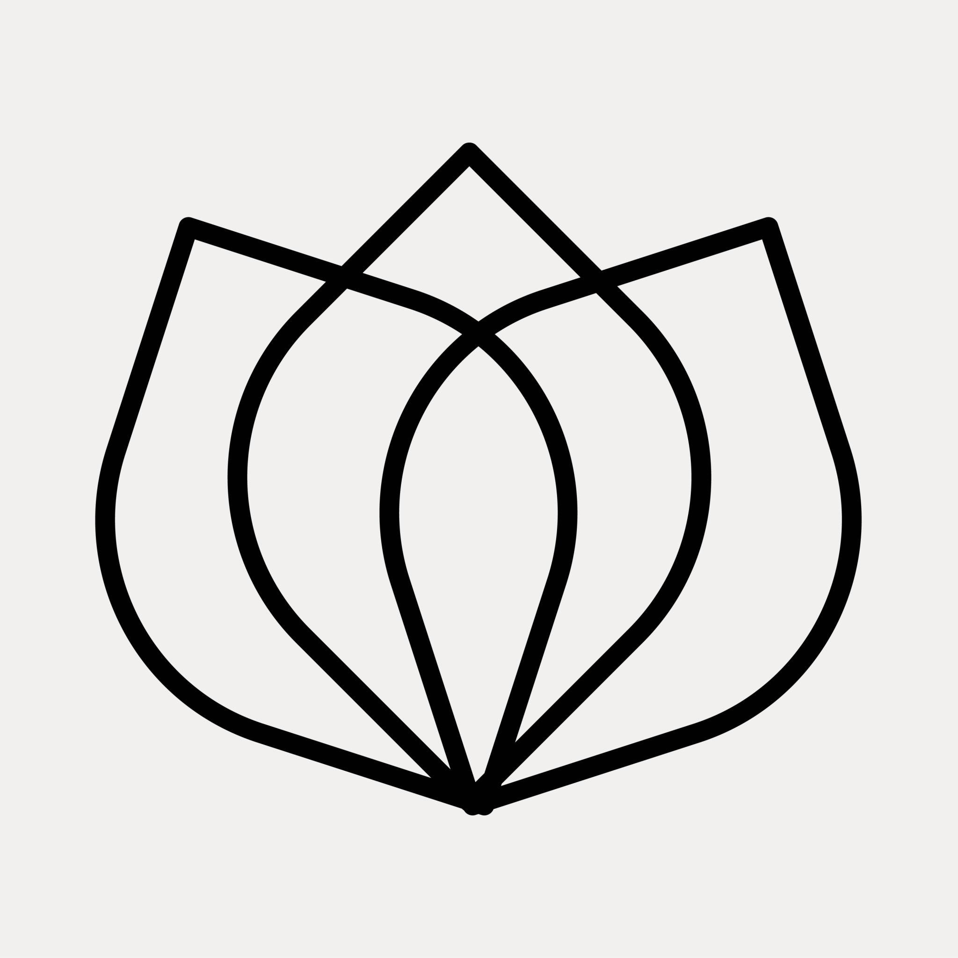
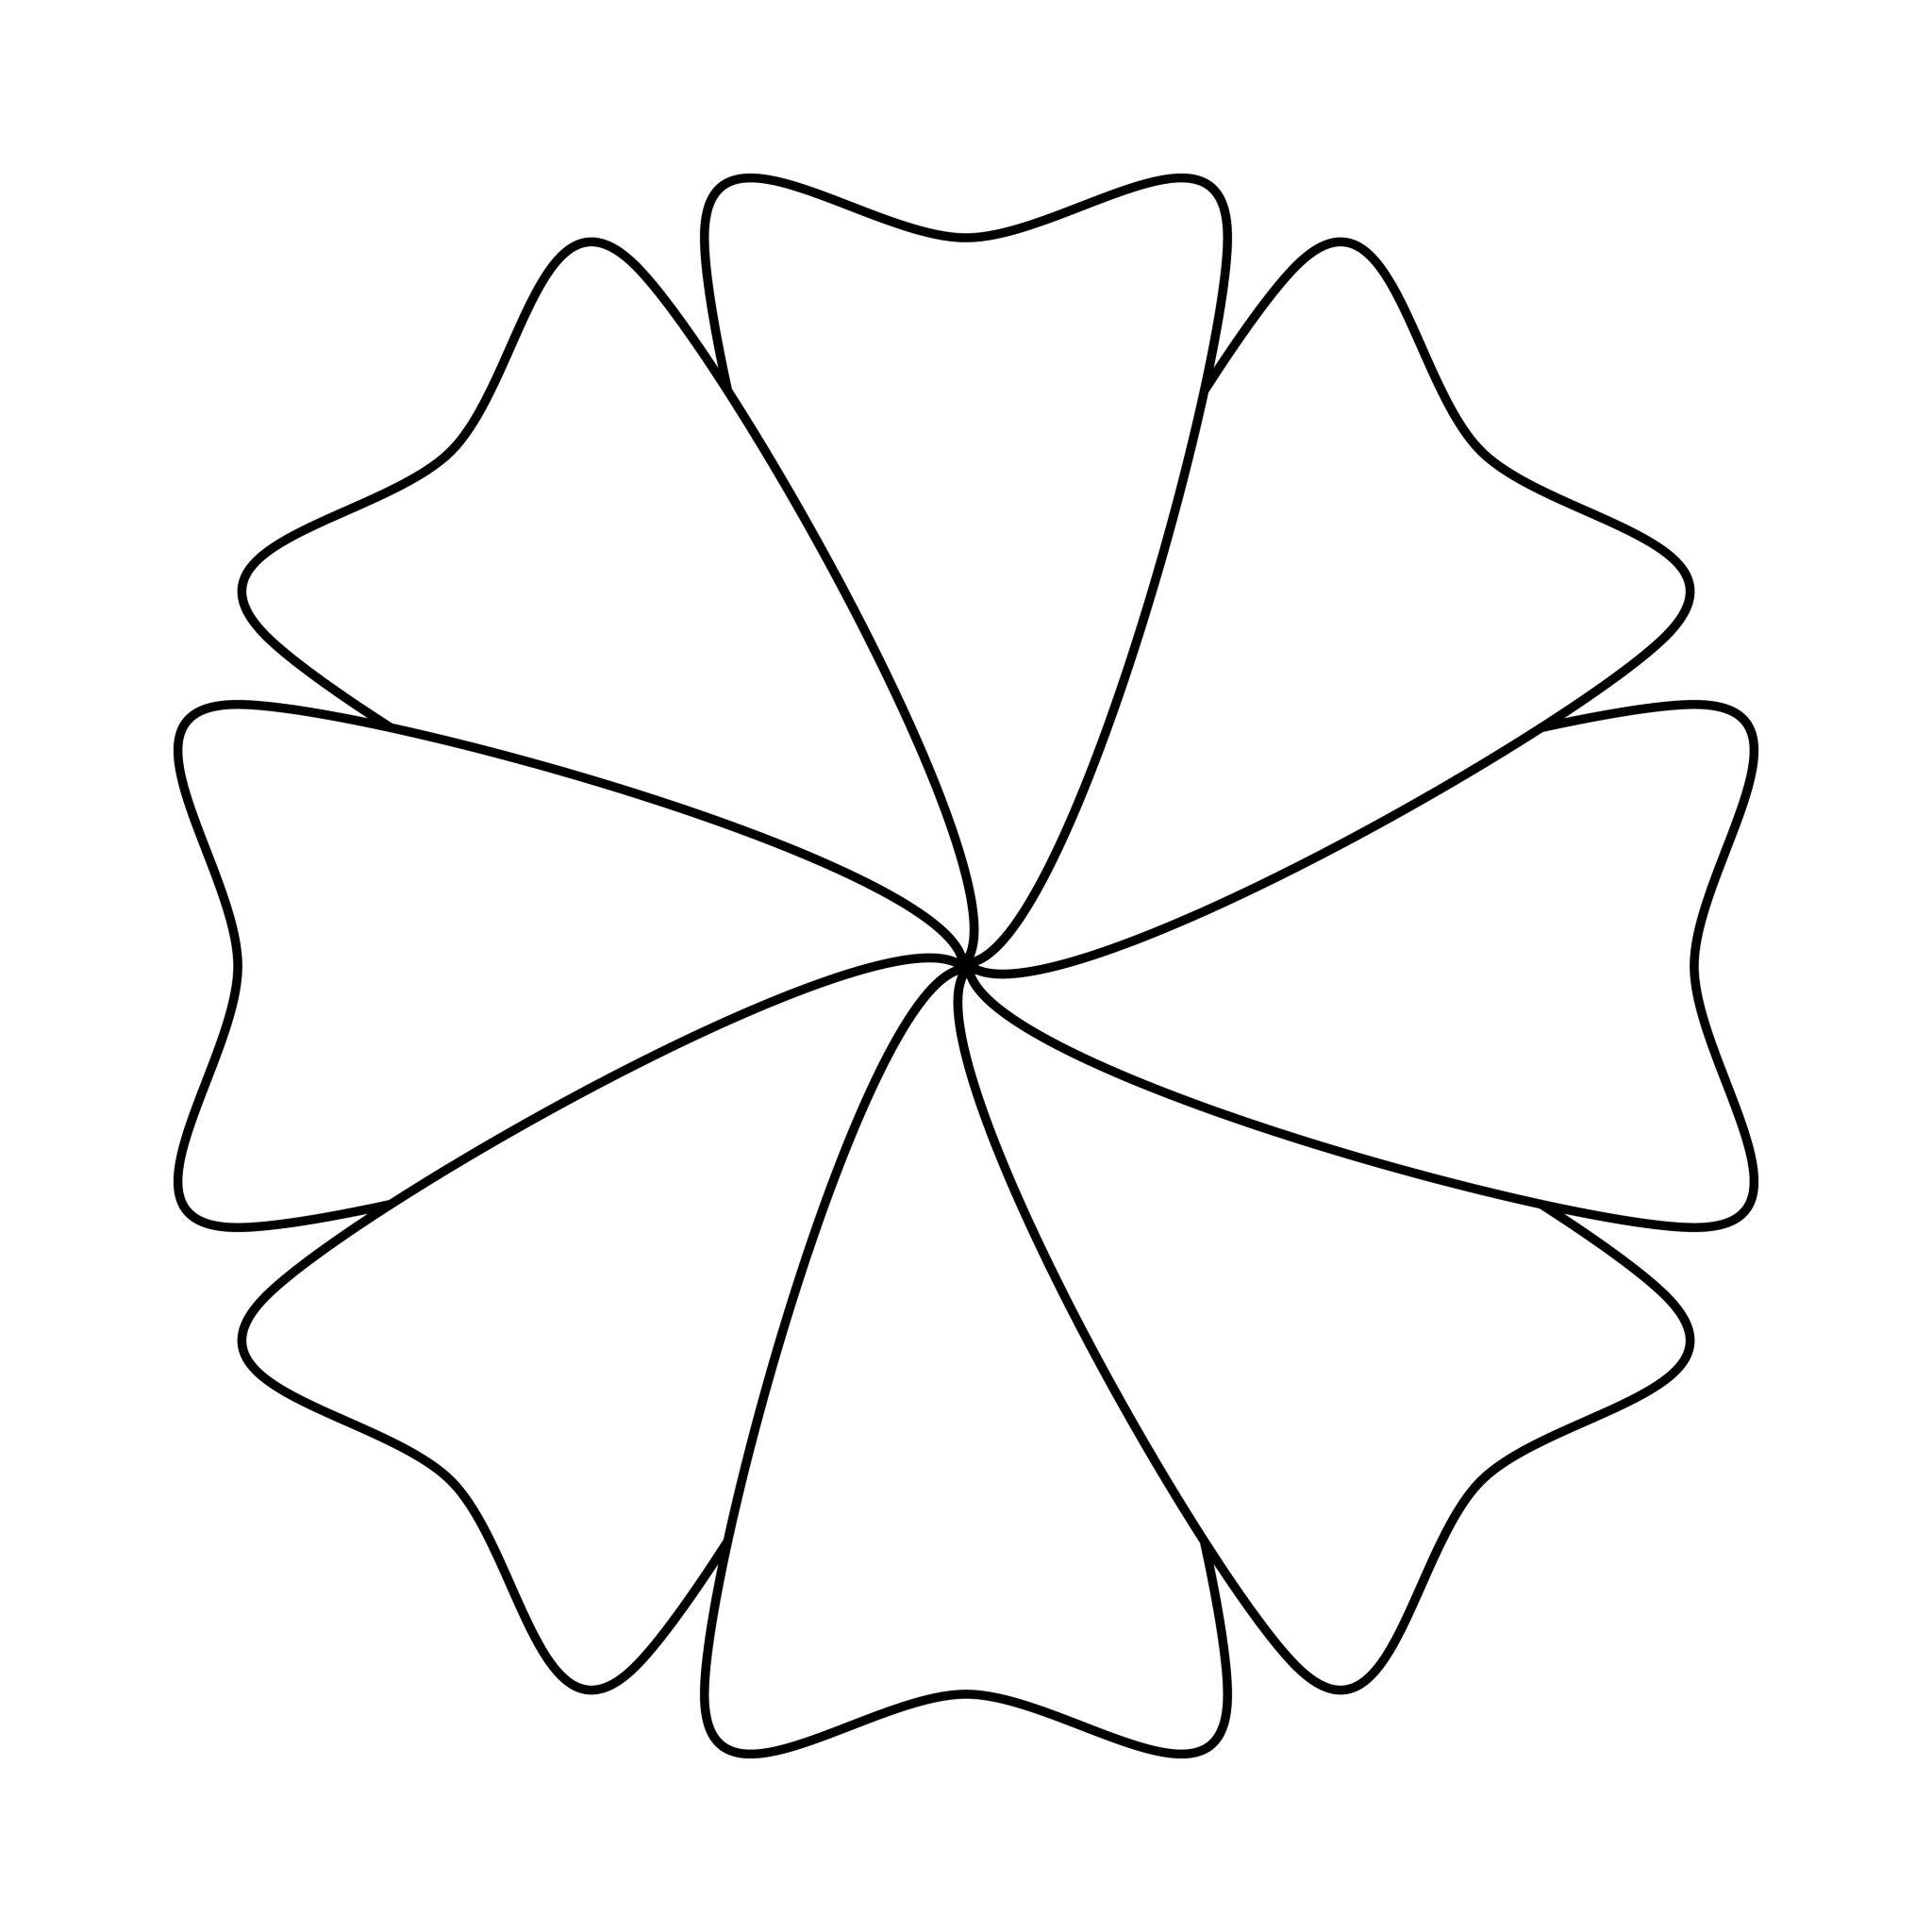
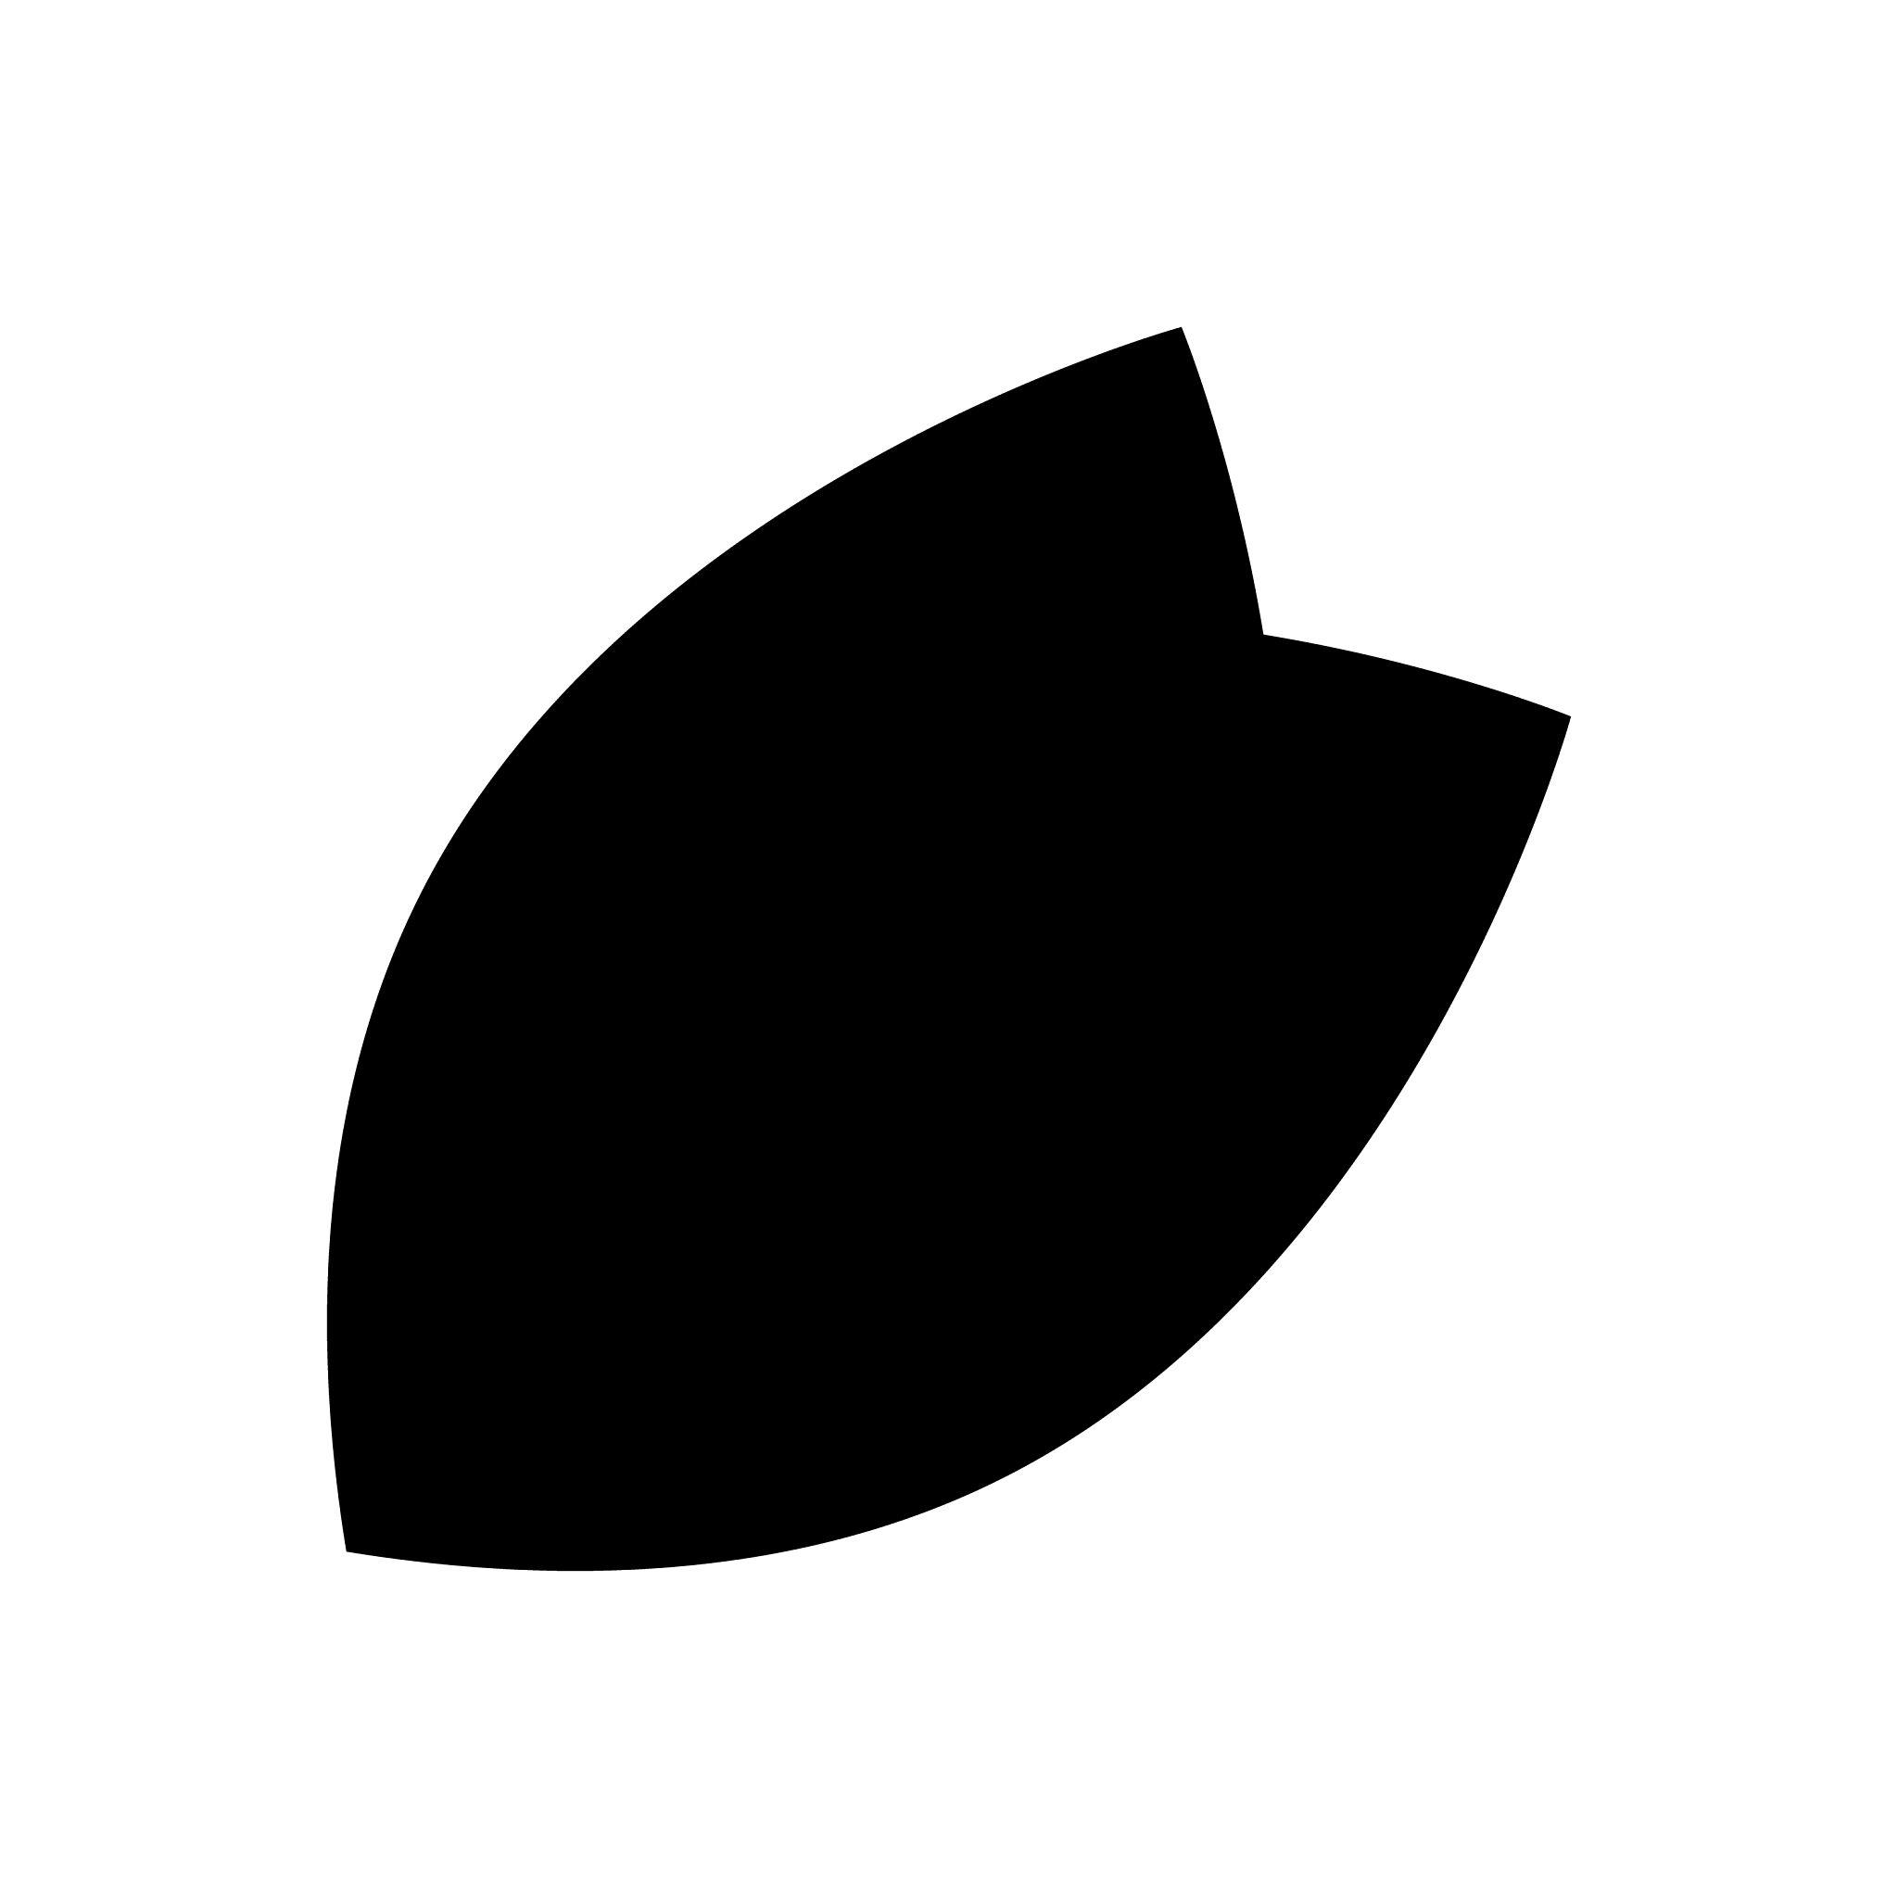
Depending on the number and arrangement of lobes, they may have:
- Rotational symmetry.
- Reflection symmetry.
- Partial symmetry.
- No symmetry.

10. Irregular Lobed Organic Closed Curves
# Source: AI Source: Provided by: [Data Path: Persons Table -> ID Column: 1, Name_En Column: Motasem Essam] -> From: [ChatGPT] on [7/25/2026]
These have several smooth rounded lobes around their boundary.
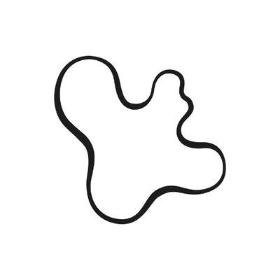
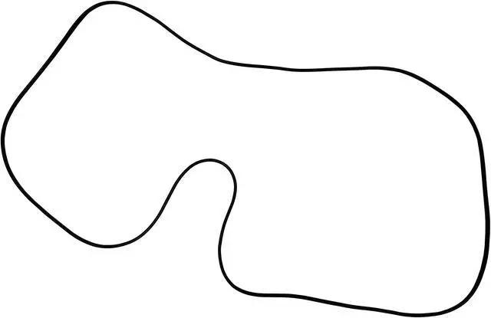
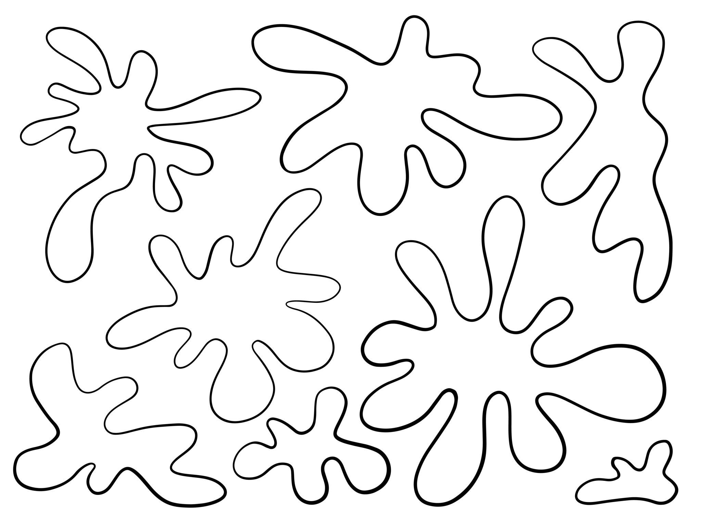
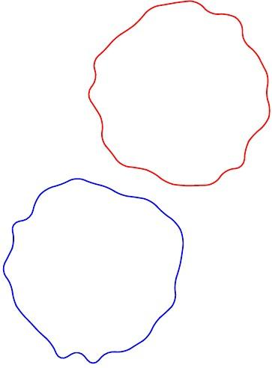
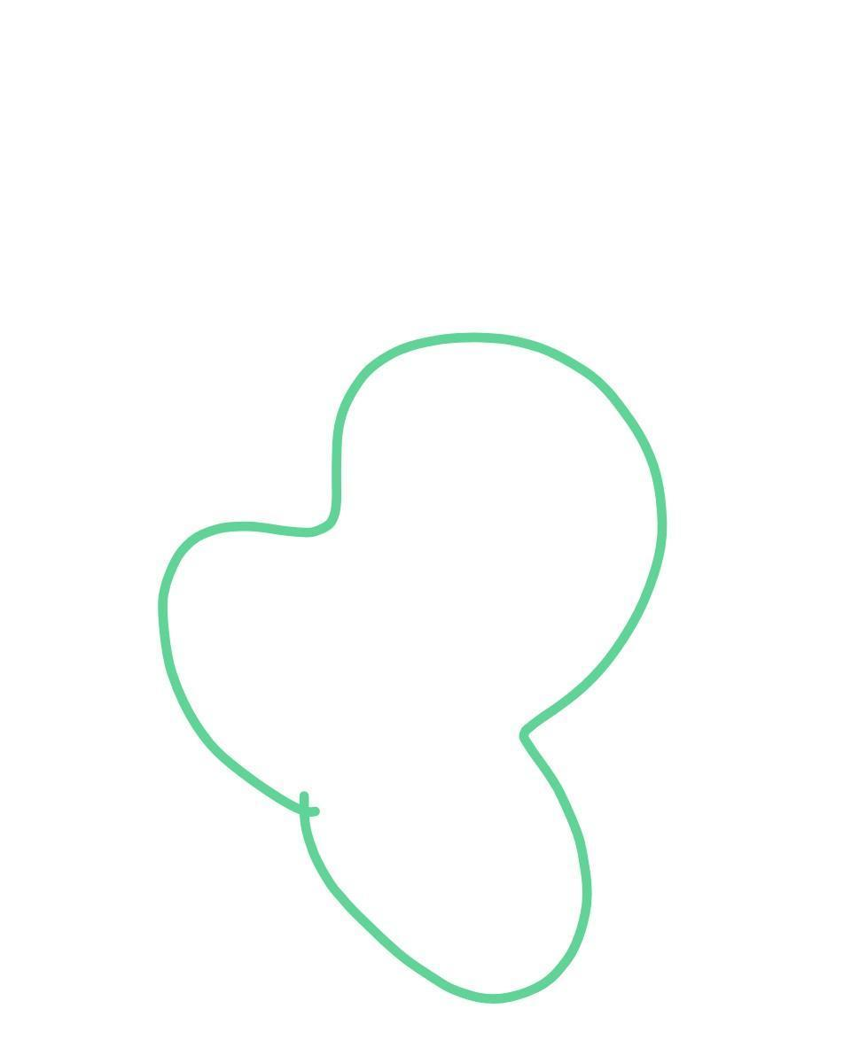
The lobes can have different:
- Sizes.
- Spacing.
- Curvatures.
- Depths.

Classification by Symmetry
# Source: AI Source: Provided by: [Data Path: Persons Table -> ID Column: 1, Name_En Column: Motasem Essam] -> From: [ChatGPT] on [7/25/2026]
Organic closed curved shapes can also be classified by symmetry.

Symmetric Organic Closed Curves
# Source: AI Source: Provided by: [Data Path: Persons Table -> ID Column: 1, Name_En Column: Motasem Essam] -> From: [ChatGPT] on [7/25/2026]
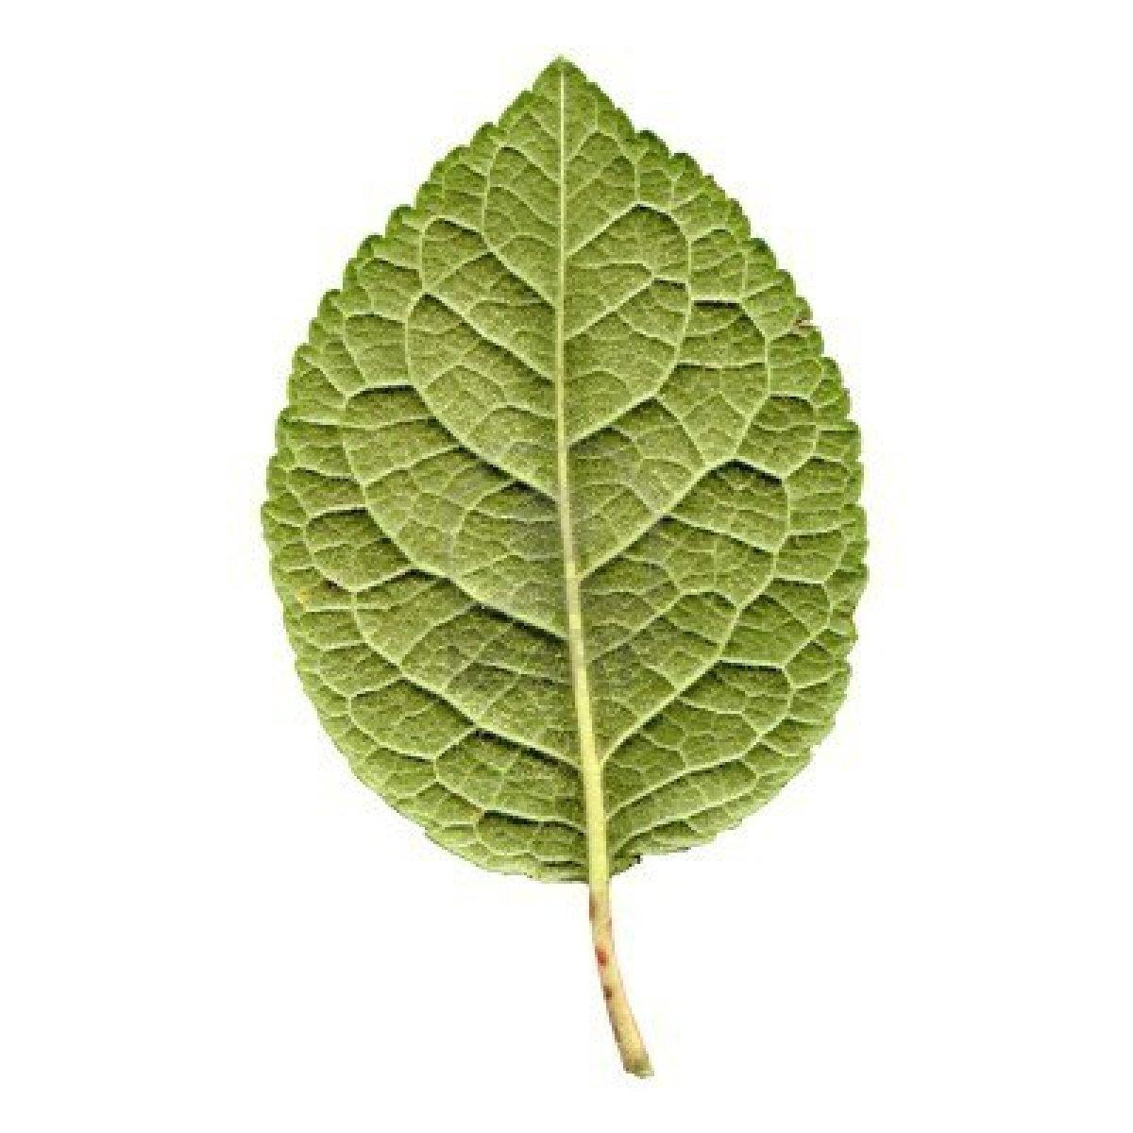
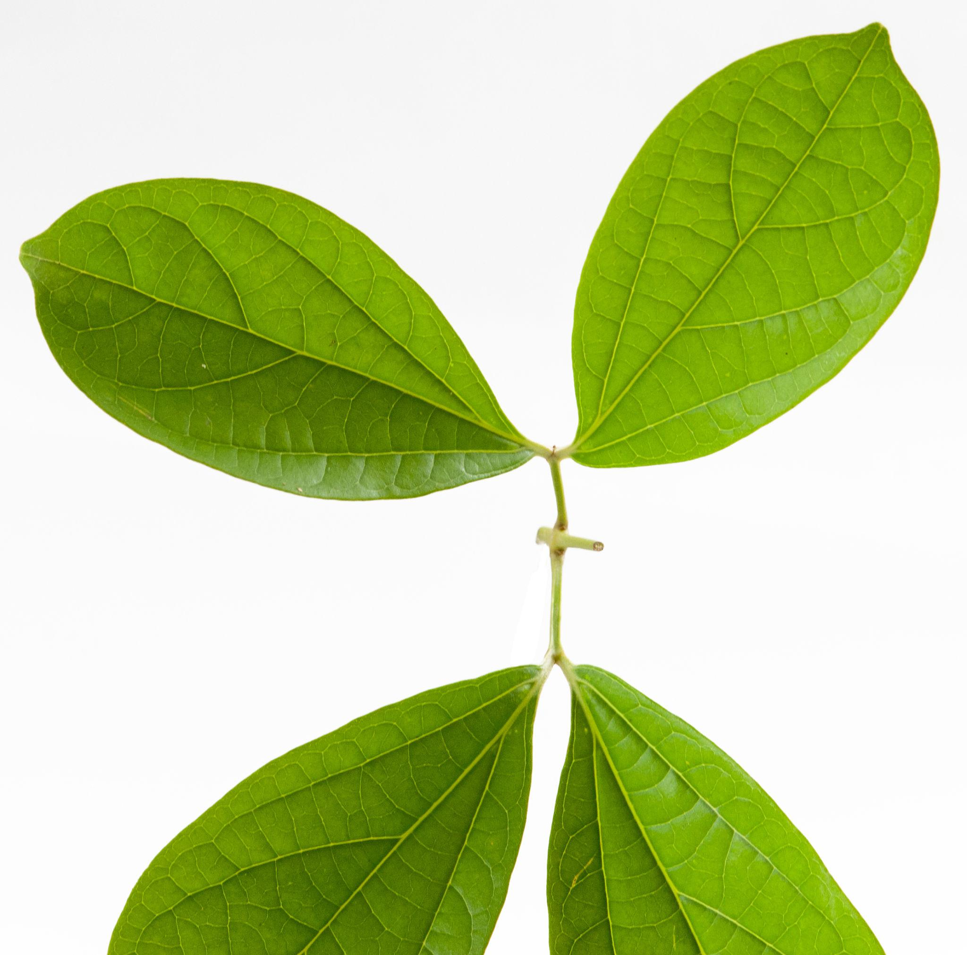
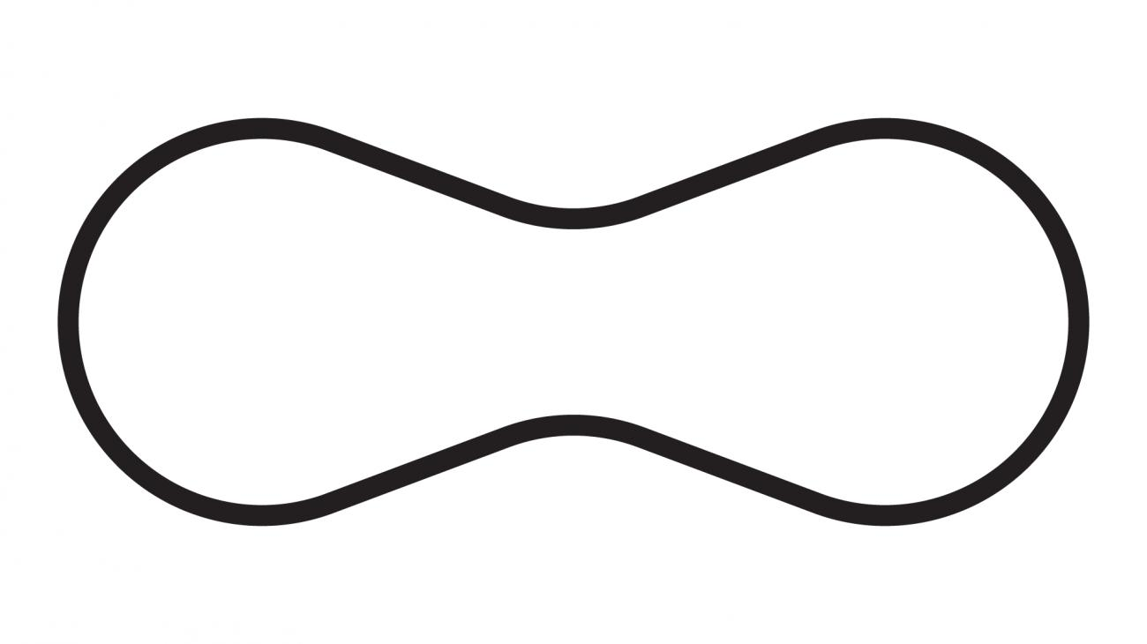
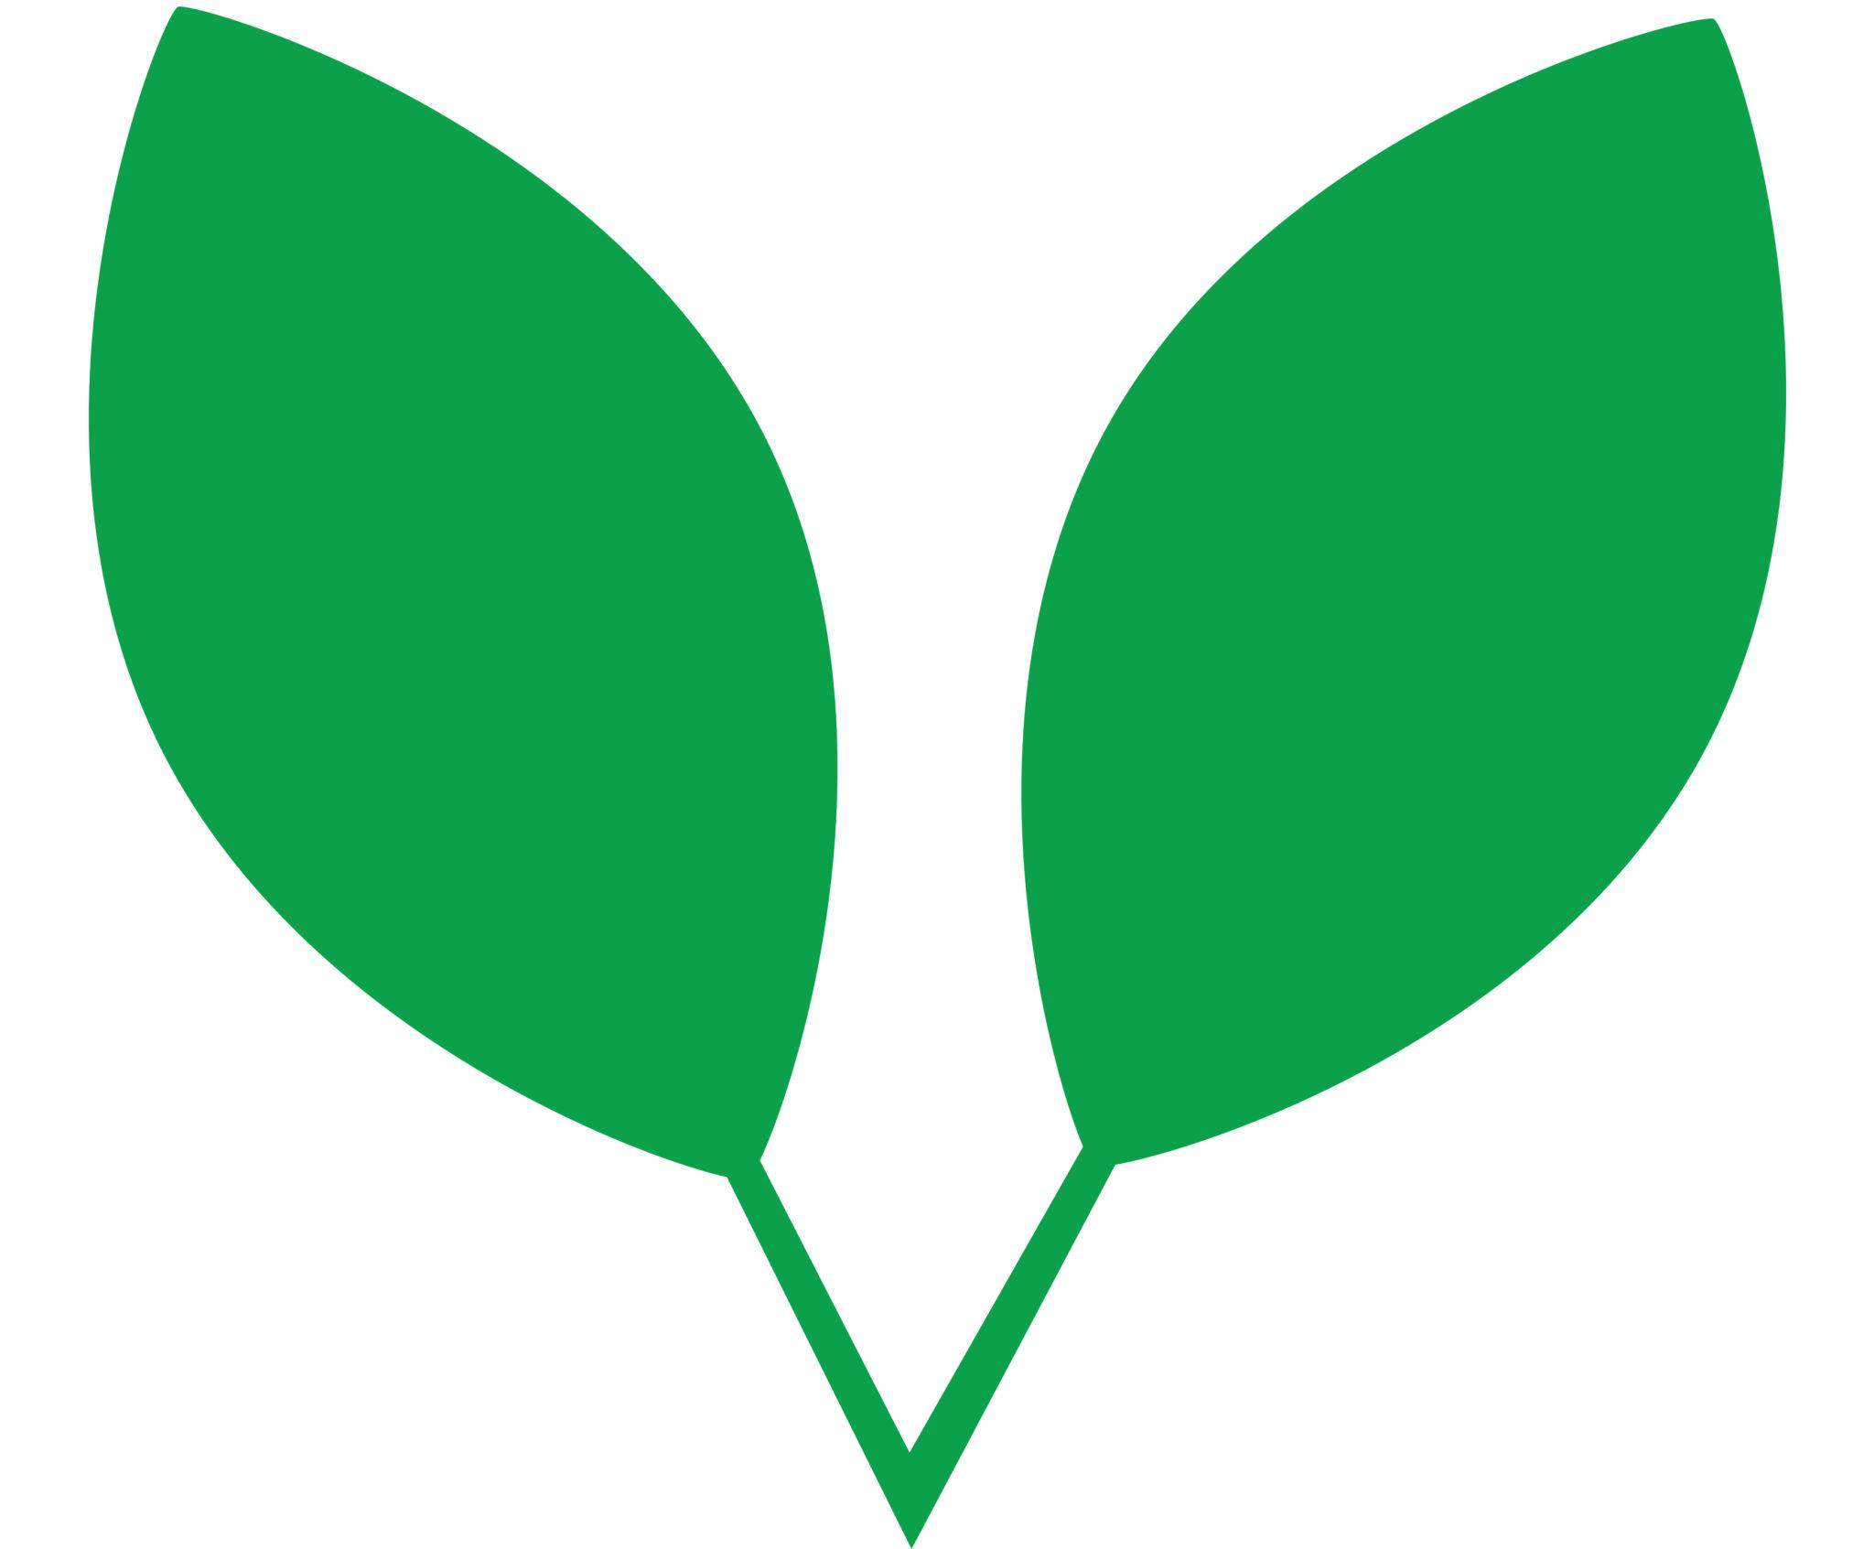
They have one or more approximate symmetry axes.

Asymmetric Organic Closed Curves
# Source: AI Source: Provided by: [Data Path: Persons Table -> ID Column: 1, Name_En Column: Motasem Essam] -> From: [ChatGPT] on [7/25/2026]
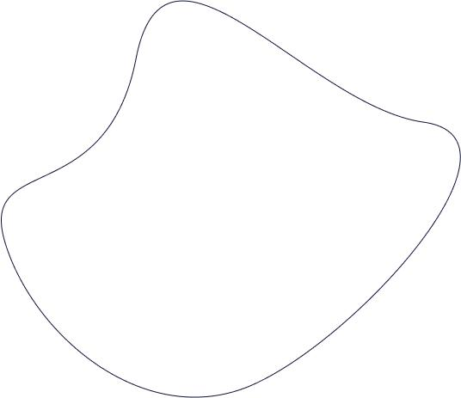
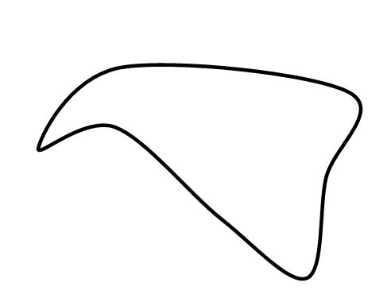
They lack a regular axis of symmetry.

Classification by Regularity
# Source: AI Source: Provided by: [Data Path: Persons Table -> ID Column: 1, Name_En Column: Motasem Essam] -> From: [ChatGPT] on [7/25/2026]
Regular-Looking Organic Shapes
These have relatively smooth and balanced forms.
Examples:
- Symmetric leaf-like forms.
- Smooth seed-like forms.
- Balanced petal-like forms.
Irregular Organic Shapes
These have variable curvature and asymmetry.
Examples:
- Pebbles.
- Clouds.
- Puddles.
- Irregular cells.
- Natural body outlines.

Organic vs. Natural Irregular Closed Curves
# Source: AI Source: Provided by: [Data Path: Persons Table -> ID Column: 1, Name_En Column: Motasem Essam] -> From: [ChatGPT] on [7/25/2026]
These two categories can overlap, but they are not exactly the same concept.
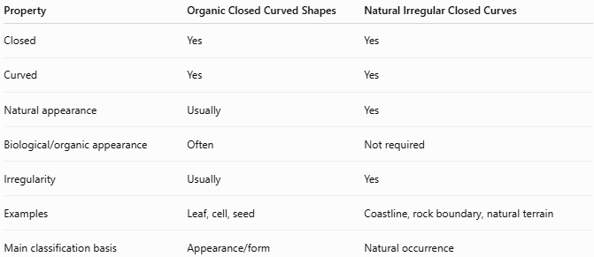
Property | Organic Closed Curved Shapes | Natural Irregular Closed Curves
Closed | Yes | Yes
Curved | Yes | Yes
Natural appearance | Usually | Yes
Biological/organic appearance | Often | Not required
Irregularity | Usually | Yes
Examples | Leaf, cell, seed | Coastline, rock boundary, natural terrain
Main classification basis | Appearance/form | Natural occurrence
For your classification system:
$$\boxed{\text{Organic}=\text{Natural-Looking Form}}$$
while:
$$\boxed{\text{Natural}=\text{Occurrence in Nature}}$$
Thus, a natural rock can be classified as Natural Irregular Closed Curve, while a leaf-like designed shape could be classified as Organic Closed Curved Shape.

Organic vs. Oval Closed Shapes
# Source: AI Source: Provided by: [Data Path: Persons Table -> ID Column: 1, Name_En Column: Motasem Essam] -> From: [ChatGPT] on [7/25/2026]
An organic shape may look oval, but the two categories are different.
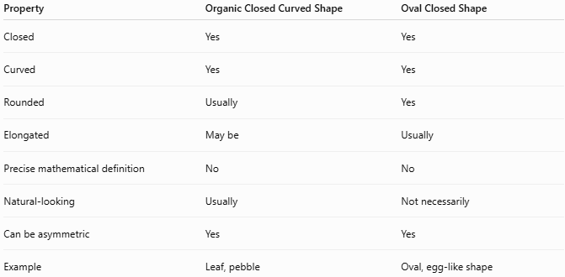
Property | Organic Closed Curved Shape | Oval Closed Shape
Closed | Yes | Yes
Curved | Yes | Yes
Rounded | Usually | Yes
Elongated | May be | Usually
Precise mathematical definition | No | No
Natural-looking | Usually | Not necessarily
Can be asymmetric | Yes | Yes
Example | Leaf, pebble | Oval, egg-like shape
Therefore:
$$\boxed{\text{Organic Shape}≠\text{Oval Shape}}$$
although an organic shape can also be oval-like.

Boundary
# Source: AI Source: Provided by: [Data Path: Persons Table -> ID Column: 1, Name_En Column: Motasem Essam] -> From: [ChatGPT] on [7/25/2026]
The boundary is a continuous closed curve:
$$\boxed{∂R=\text{continuous curved boundary}}$$
and:
$$\boxed{P_{\text{start}}=P_{\text{end}}}$$
The boundary separates the enclosed interior from the exterior.
$$\boxed{\text{Interior}+\text{Organic Curved Boundary}+\text{Exterior}}$$

Area
# Source: AI Source: Provided by: [Data Path: Persons Table -> ID Column: 1, Name_En Column: Motasem Essam] -> From: [ChatGPT] on [7/25/2026]
Because the curve is closed, it encloses a bounded region.
For a general organic closed curve, there is no universal elementary area formula.
The area can be determined through:
- Coordinate geometry.
- Numerical approximation.
- Integration.
- Image analysis.
- CAD measurements.
For a parametrically defined closed curve:
$$x=x\left(t\right), y=y\left(t\right)$$
the enclosed area can be calculated using Green's theorem:
[
$$\boxed{A=\frac{1}{2}\oint{\left(x,dy-y,dx\right)}}$$]

Boundary Length
# Source: AI Source: Provided by: [Data Path: Persons Table -> ID Column: 1, Name_En Column: Motasem Essam] -> From: [ChatGPT] on [7/25/2026]
The boundary length is the arc length of the organic curve.
For a parametric representation:
$$\boxed{L=\int_{a}^{b}{\sqrt{{\left(\frac{dx}{dt}\right)}^{2}+{\left(\frac{dy}{dt}\right)}^{2}}}dt}$$
where the curve closes:
$$\left(x\left(a\right),y\left(a\right)\right)=\left(x\left(b\right),y\left(b\right)\right).$$

Key Points
# Source: AI Source: Provided by: [Data Path: Persons Table -> ID Column: 1, Name_En Column: Motasem Essam] -> From: [ChatGPT] on [7/25/2026]
An Organic Closed Curved Shape is:
$$\boxed{\text{Closed}+\text{Curved}+\text{Natural-Looking}+\text{Irregular}}$$
It:
- Has a continuous closed boundary.
- Encloses a bounded region.
- Has no open endpoints.
- Usually has no straight sides or sharp vertices.
- Does not necessarily follow a standard mathematical equation.
- May be symmetric or asymmetric.
- Can resemble natural or biological forms.

Conclusion
# Source: AI Source: Provided by: [Data Path: Persons Table -> ID Column: 1, Name_En Column: Motasem Essam] -> From: [ChatGPT] on [7/25/2026]
Organic Closed Curved Shapes are closed, smooth, natural-looking curves with irregular or non-standard geometry. They include leaf-like, pebble-like, cloud-like, seed-like, cell-like, droplet-like, puddle-like, petal-like, and irregular lobed forms. Their defining feature is organic appearance combined with a closed curved boundary, distinguishing them from mathematically defined circular and elliptical shapes and from artificially designed freeform curves.

